

IST707 – Data Analytics

Prof.: Dr. Bolton

Homework 6&7 Report:

kNN, Random Forest, SVM, Decision Tree and Naïve Bayes

**Name: Yehuda Perry**

**Course: IST707 – Data Analytics**

**Professor: Dr. Bolton**

**Homework: 6 & 7 (Combined)**

**Date: 05/18/2020**

Table of Contents

1. Introduction 4

1.1 Naïve Bayes 4

1.2 Decision Tree 5

1.3 K-nearest neighbors (kNN) 7

1.4 Random Forest 8

1.5 Support Vector Machine (SVM) 9

1.6 Research Instructions (HW6) 11

1.7 Research Instructions (HW7) 11

2. Analysis and Models 13

2.1 About the data 13

2.2 Libraries, Data Loading and Exploring the Data 13

2.3 Data Transformation and Cleansing 21

2.3.1. Creating Samples 21

2.3.2. Removing pixels that have 0 in all images 21

2.3.3. Removing pixels with low variance 21

2.3.4. Sorting variance and creating number labels for variance Incl. summary of all variance 22

2.3.5. Plotting all variances 22

2.3.6. Creating clean train set with good variance 23

2.3.7. Normalizing the data 23

2.3.8. Creating Test and Train sets for the Training Data Set 24

2.4 kNN, Random Forest and SVM (Part II) 25

2.4.1 Building the kNN Model – Train and testing sets 25

2.4.2 kNN - Choosing the K and Building the model 25

2.4.3 kNN - Confusion Matrix and Accuracy 26

2.4.4 Random Forest – Building the Random Forest Model 27

2.4.5 Random Forest – Confusion Matrix and Accuracy 27

2.4.6 Plotting RF Model 28

2.4.7 SVM Model – Building the Model 30

2.4.8 SVM Model – Predication 30

2.4.9 SVM Model – Confusion Matrix and Accuracy 31

2.4.10 Naïve Bayes – Building the Model 32

2.4.11 Naïve Bayes - Predication 52

2.4.12 Naïve Bayes - Confusion Matrix and Accuracy 52

2.4.13 Decision Tree – Building the Model 53

2.4.14 Decision Tree – Predication 54

2.4.15 Decision Tree – Confusion Matrix and Accuracy 54

2.4.16 Decision Tree – Visualizations 55

3.0 Results 57

4.0 Conclusions 58

5.0 References 59

# Introduction

MNIST ("Modified National Institute of Standards and Technology") is the de facto “hello world” dataset of computer vision. Since its release in 1999, the classic dataset of handwritten images has served as the basis for benchmarking classification algorithms. As new machine learning techniques emerge, MNIST remains a reliable resource for researchers and learners alike.[1]

In the Kaggle competition, the goal is to correctly identify digits from a dataset of tens of thousands of handwritten images using machine learning algorithms. This paper will discuss digit recognizer using Naïve Bayes, Decision Tree, kNN, Random Forest and SVM algorithms.

# Naïve Bayes

Naive Bayes has three flaws when applied to document classification. First, a word’s non-appearance counts just as much its appearance, whereas surely a document’s class is determined by the words that are in it rather than those that aren’t? Second, Naive Bayes doesn’t take account of the number of appearances of a word, whereas surely frequently occurring words should have a greater influence on the class than ones that only appear once? Third, it treats all words the same, whereas surely unusual words like “weka” and “breakfast” should count more than common ones like “and” and “the”? Multinomial Naive Bayes is a classification method that solves these problems and is generally better and faster than plain Naive Bayes.

Naive Bayes model is easy to build and particularly useful for very large data sets. Along with simplicity, Naïve Bayes is known to outperform even highly sophisticated classification methods. Bayes theorem provides a way of calculating posterior probability P(c|x) from P(c), P(x) and P(x|c) as the following equation below:

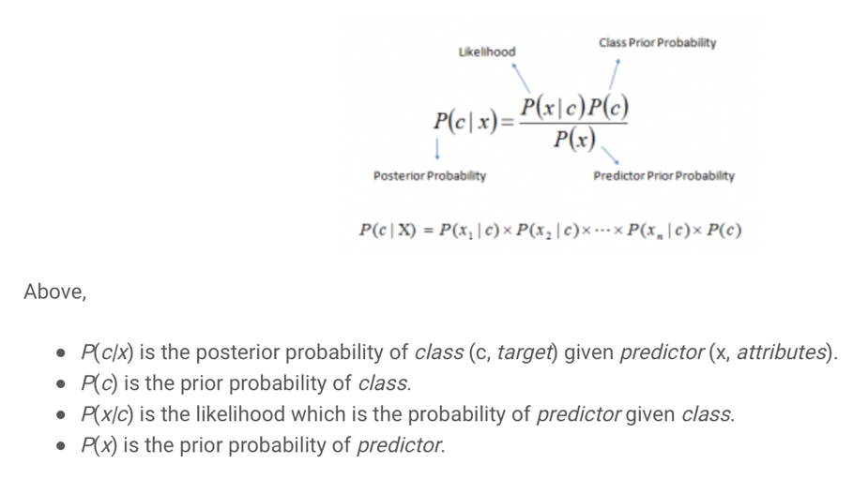

**Figure 1: Bayes Theorem**

# Decision Tree

Decision Trees (DTs) are a non-parametric supervised learning method used for classification and regression. Decision trees learn from data to approximate a sine curve with a set of if-then-else decision rules. The deeper the tree, the more complex the decision rules and the fitter the model.

Decision tree builds classification or regression models in the form of a tree structure. It breaks down a data set into smaller and smaller subsets while at the same time an associated decision tree is incrementally developed. The final result is a tree with decision nodes and leaf nodes. A decision node has two or more branches. Leaf node represents a classification or decision. The topmost decision node in a tree which corresponds to the best predictor called root node. Decision trees can handle both categorical and numerical data.

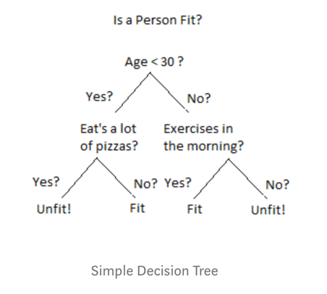

**Figure 2: Sample Decision Tree**

**How Do Decision Trees Work?** There are several steps involved in the building of a decision tree. **Splitting:** The process of partitioning the data set into subsets. Splits are formed on a particular variable.

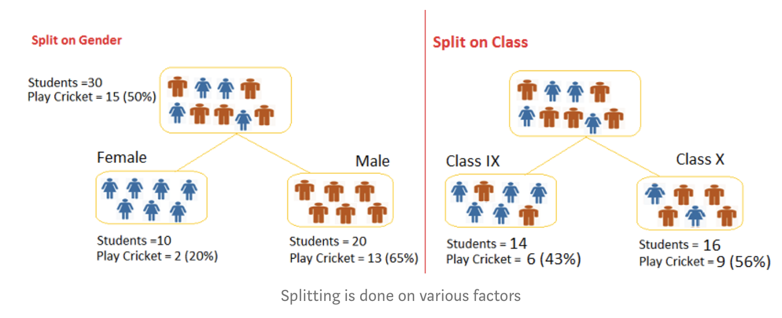

**Figure 3: Decision Tree Splitting**

**Pruning:** he shortening of branches of the tree. Pruning is the process of reducing the size of the tree by turning some branch nodes into leaf nodes, and removing the leaf nodes under the original branch. Pruning is useful because classification trees may fit the training data well, but may do a poor job of classifying new values. A simpler tree often avoids over-fitting.

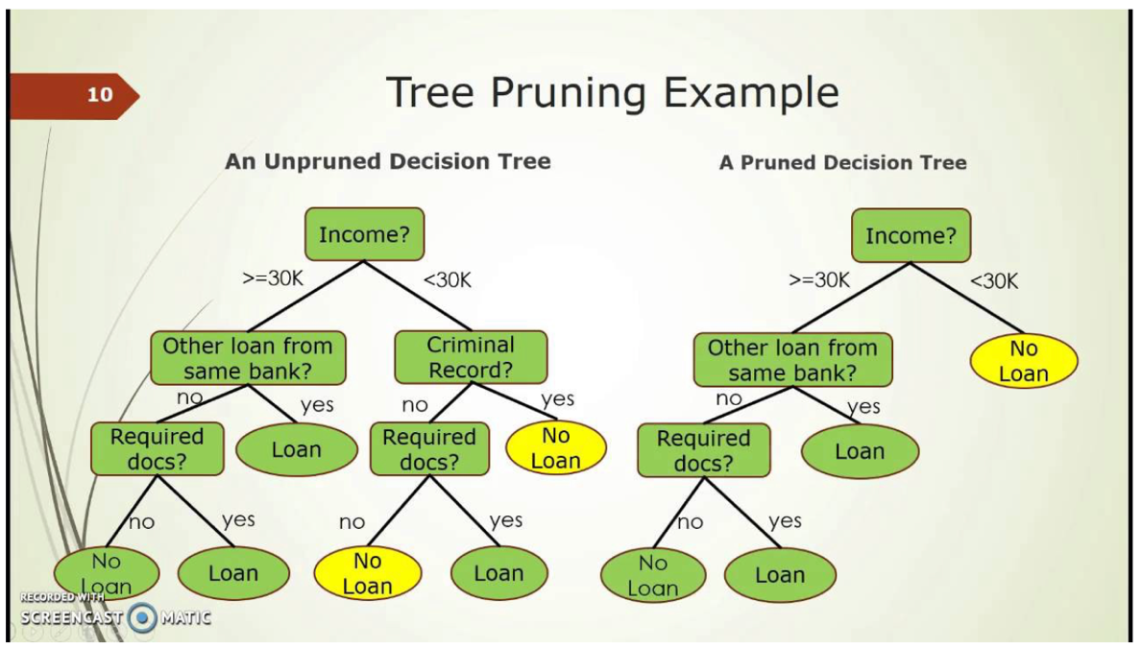

**Figure 4: Tree Pruning Example**

As we can see above, a pruned tree has less nodes and has less sparsity than a unpruned decision tree.

**Tree Selection:** The process of finding the smallest tree that fits the data. Usually this is the tree that yields the lowest cross-validated error.

# K-nearest neighbors (kNN)

K nearest neighbors is a simple algorithm that stores all available cases and classifies new cases based on a similarity measure (e.g., distance functions). KNN has been used in statistical estimation and pattern recognition already in the beginning of 1970’s as a non-parametric technique.

A case is classified by a majority vote of its neighbors, with the case being assigned to the class most common amongst its K nearest neighbors measured by a distance function. If K = 1, then the case is simply assigned to the class of its nearest neighbor.

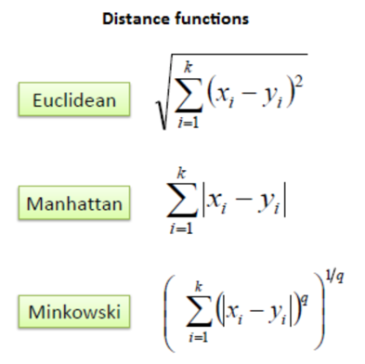

**Figure 5: Distance Function**

It should also be noted that all three distance measures are only valid for continuous variables. In the instance of categorical variables, the Hamming distance must be used. It also brings up the issue of standardization of the numerical variables between 0 and 1 when there is a mixture of numerical and categorical variables in the dataset.

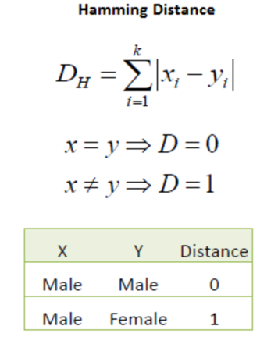

**Figure 6: Hamming Distance**

Choosing the optimal value for K is best done by first inspecting the data. In general, a large K value is more precise as it reduces the overall noise but there is no guarantee. Cross-validation is another way to retrospectively determine a good K value by using an independent dataset to validate the K value. Historically, the optimal K for most datasets has been between 3-10. That produces much better results than 1NN.

# Random Forest

Random forest is a flexible, easy to use machine learning algorithm that produces, even without hyper-parameter tuning, a great result most of the time. It is also one of the most used algorithms, because of its simplicity and diversity (it can be used for both classification and regression tasks).

Random forest is a supervised learning algorithm. The "forest" it builds, is an ensemble of decision trees, usually trained with the “bagging” method. The general idea of the bagging method is that a combination of learning models increases the overall result.

One big advantage of random forest is that it can be used for both classification and regression problems, which form the majority of current machine learning systems. Let's look at random forest in classification, since classification is sometimes considered the building block of machine learning. Below is how a random forest would look like with two trees:

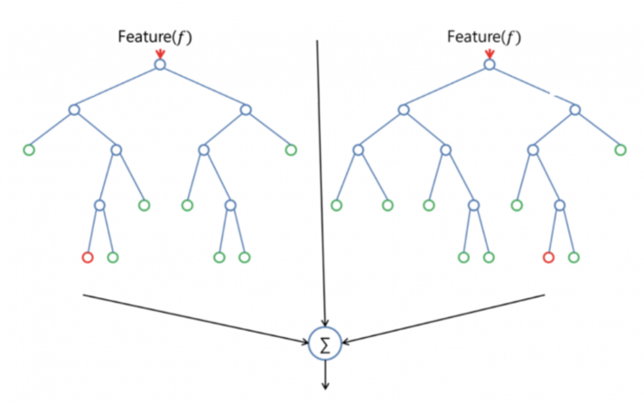

**Figure 7: Random Forest two trees**

Random forest has nearly the same hyperparameters as a decision tree or a bagging classifier. Fortunately, there's no need to combine a decision tree with a bagging classifier because it can easily use the classifier-class of random forest. With random forest, it can also deal with regression tasks by using the algorithm's regressor.

Random forest adds additional randomness to the model, while growing the trees. Instead of searching for the most important feature while splitting a node, it searches for the best feature among a random subset of features. This results in a wide diversity that generally results in a better model.

Therefore, in random forest, only a random subset of the features is taken into consideration by the algorithm for splitting a node. It can even make trees more random by additionally using random thresholds for each feature rather than searching for the best possible thresholds (like a normal decision tree does).[2]

# Support Vector Machine (SVM)

The objective of the support vector machine algorithm is to find a hyperplane in an N-dimensional space (N — the number of features) that distinctly classifies the data points.

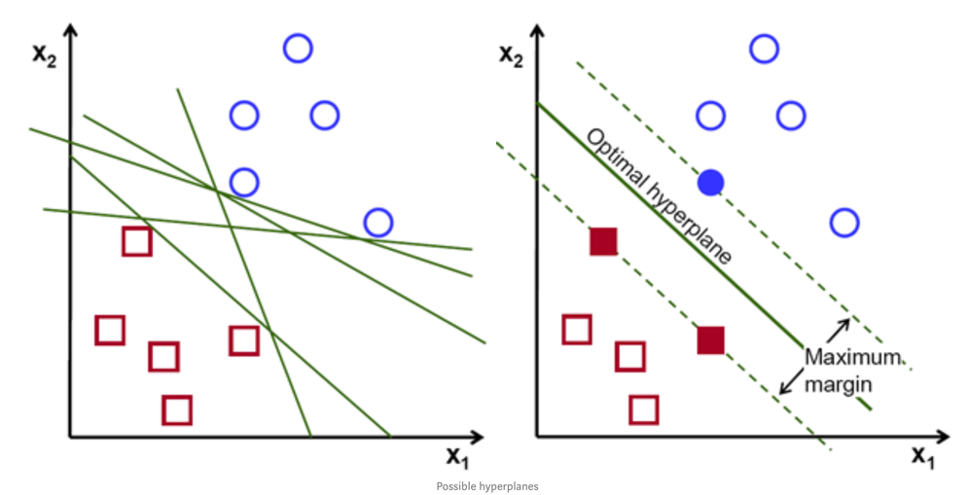

**Figure 8: Possible Hyperplane**

To separate the two classes of data points, there are many possible hyperplanes that could be chosen. Our objective is to find a plane that has the maximum margin, i.e the maximum distance between data points of both classes. Maximizing the margin distance provides some reinforcement so that future data points can be classified with more confidence.

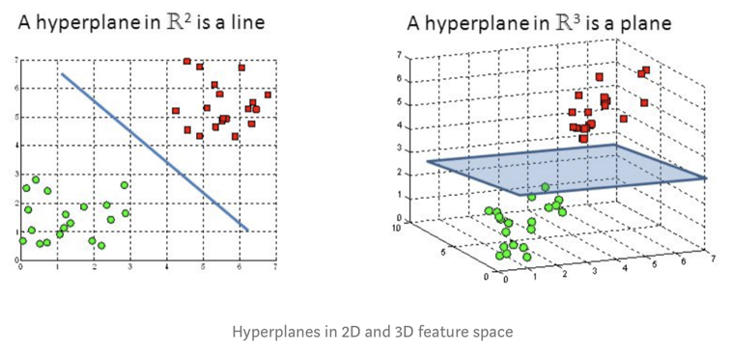

**Figure 9: Hyperplane in 2D and 3D**

Hyperplanes are decision boundaries that help classify the data points. Data points falling on either side of the hyperplane can be attributed to different classes. Also, the dimension of the hyperplane depends upon the number of features. If the number of input features is 2, then the hyperplane is just a line. If the number of input features is 3, then the hyperplane becomes a two-dimensional plane. It becomes difficult to imagine when the number of features exceeds 3.

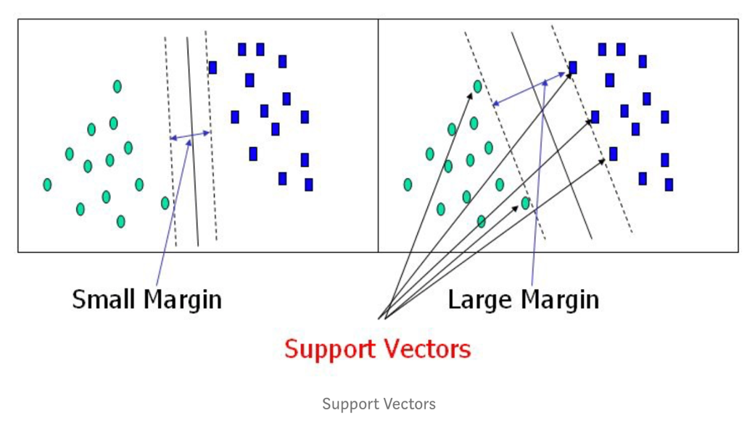

**Figure 10: Support Vectors**

Support vectors are data points that are closer to the hyperplane and influence the position and orientation of the hyperplane. Using these support vectors, it maximizes the margin of the classifier. Deleting the support vectors will change the position of the hyperplane. These are the points that help to build SVM.

# Research Instructions (HW6)

Now that we have learned two classification algorithms, decision tree and Naïve Bayes, let’s think further on the question of choosing algorithms for a specific task. Note that there is no silver bullet in terms of algorithm comparison – no algorithm would outperform all other algorithms on all data sets. Therefore, choosing appropriate algorithms is an important decision, and it requires knowledge of both the data set and the candidate algorithms. In this homework, you will compare Naïve Bayes and decision tree for handwriting recognition.

**Task Description**

The data set comes from the Kaggle Digit Recognizer competition. The goal is to recognize digits 0 to 9 in handwriting images. Because the original data set is too large to be loaded in Weka GUI, I have systematically sampled 10% of the data by selecting the 10, 20 examples and so on. You are going to use the sampled data to construct prediction models using Naïve Bayes and decision tree algorithms. Tune their parameters to get the best model (measured by cross validation) and compare which algorithms provide better model for this task.

Due to the large size of the test data, submission to Kaggle is not required for this task. However, 1 extra point will be given to successful submissions. One solution for the large test set is to separate it to several smaller test set, run prediction on each subset, and merge all prediction results to one file for submission. You can also try use the entire training data set, or re-sample a larger sample.

<https://www.kaggle.com/c/digit-recognizer/data>

Tip: check out the Kaggle forum to see if there are some patterns other people have found that you can use to build better models.

# Research Instructions (HW7)

In this homework, you will use SVMs, kNN, and Random Forest algorithms for handwriting recognition, and compare their performance with the Naïve Bayes and decision tree models you built in previous week.

Steps:

1. Describe data pre-processing steps and the chosen evaluation method and measure(s)
2. Use the train set to build kNN, SVM, and Random Forest models. Submit these models’ prediction results to Kaggle. Report test performance, compare them, and use the theoretic knowledge to explain whether the algorithm performance difference makes sense or not.
3. Write a report to describe what you did, including the data preparation, transformation, algorithm tuning, the generated models and their performance. In the end, summarize which model works the best and why.
4. If you use Weka to do the experiment, write your report in Microsoft Word. Up to 8 pages. NO PDF PLEASE.
5. If you use R, use R Markdown tool to prepare your document and output to Word. Don't print out excessively large amount of output, such as prediction results, or the entire dataset.

# Analysis and Models

# About the data

**Dataset name:** ‘train’ and ‘test’ (From Kaggle)

**Dataset format:** csv files

**Description:** train: 42000 obs with 784 variables

test: 28000 obs with 784 variables

**Data Dictionary:** Data Dictionary was evaluated to support the dataset.

**Reference R Code: ‘**

# Libraries, Data Loading and Exploring the Data

First, Loading require packages to R to restructure and visualize the dataset.

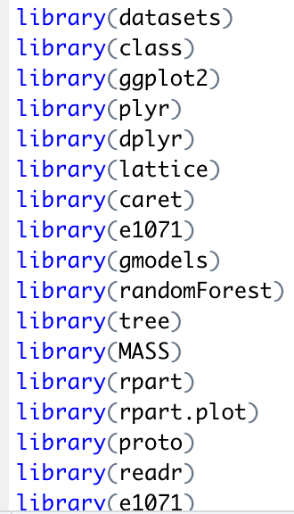

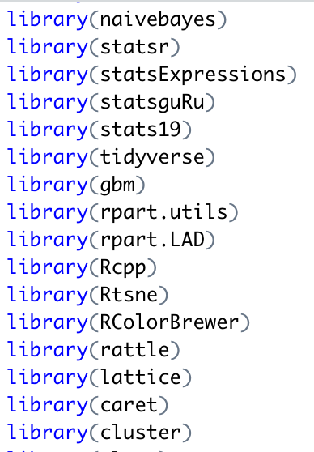

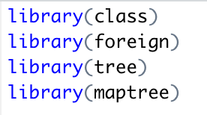

**Figure 11: Loading require R packages**

The next step is to load and read both train and test datasets.

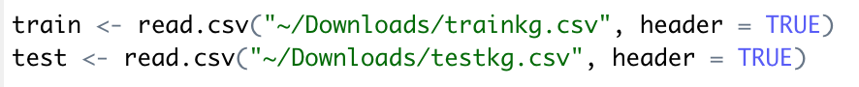

**Figure 12: Load and read the datasets**

Now, exploring the data structure:

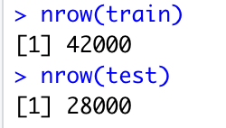

**Figure 13: nrow**

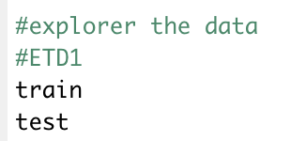

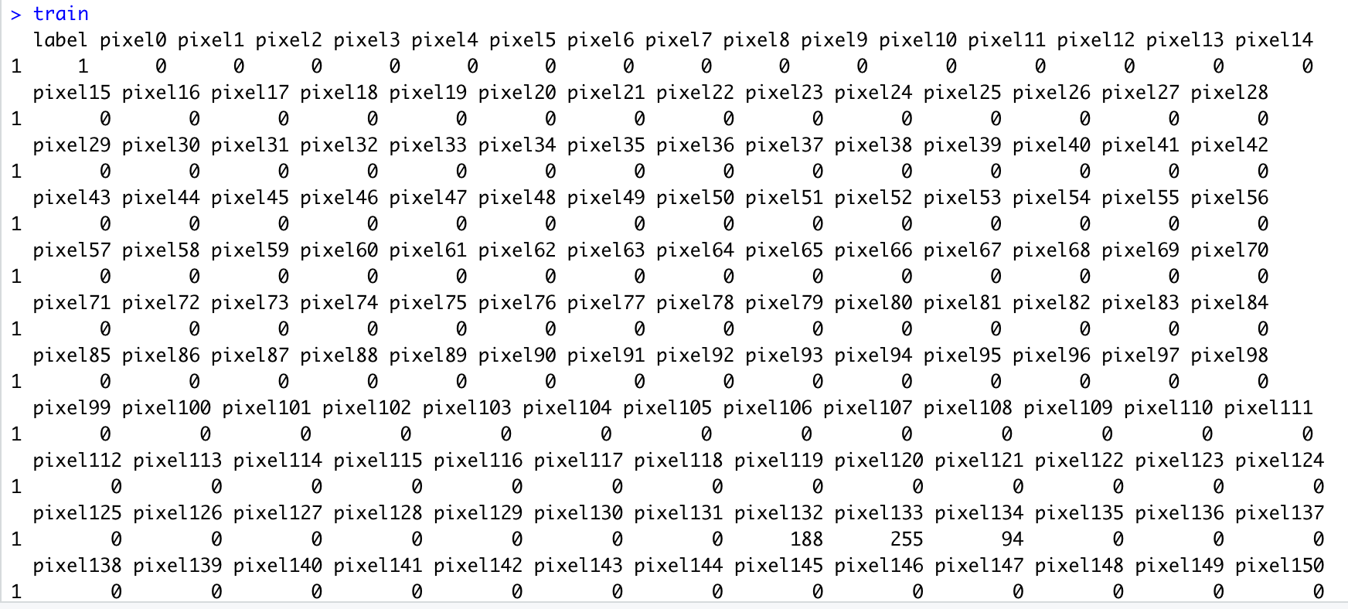

**Figure 14: train dataset**

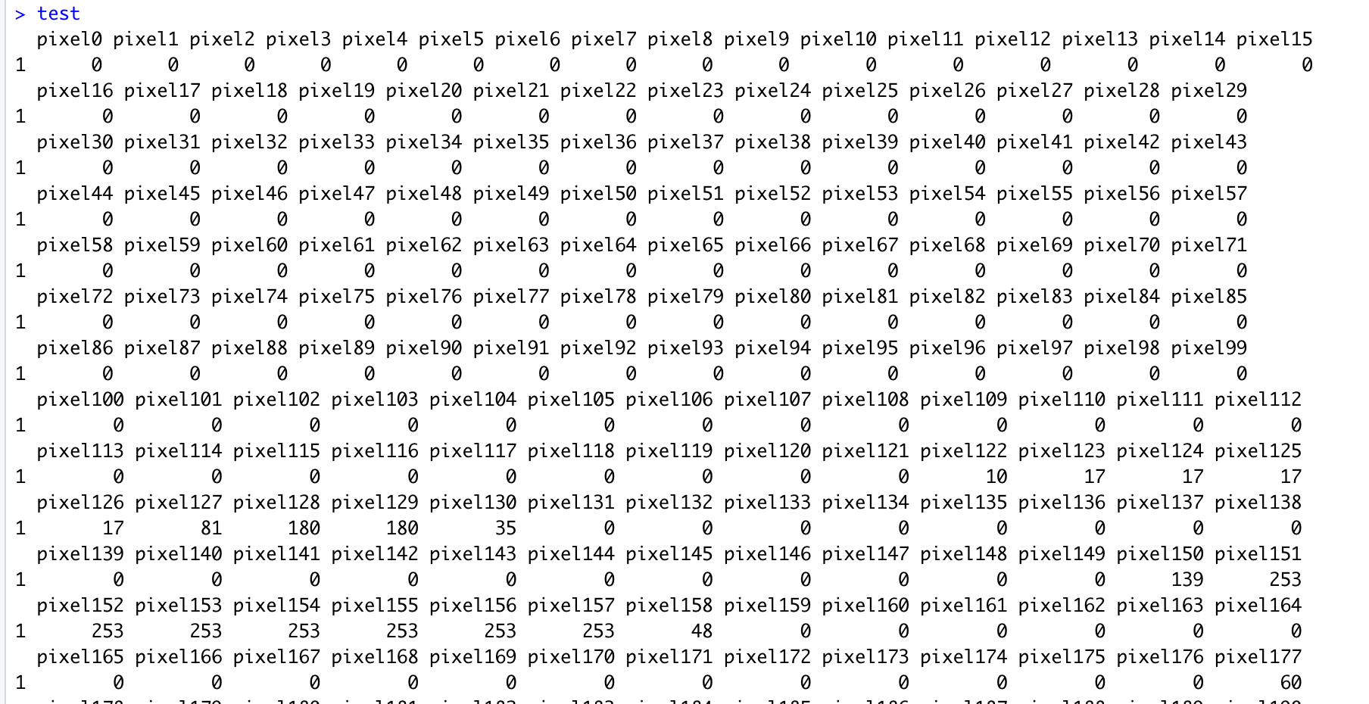

**Figure 15: test dataset**

**Head(train)**

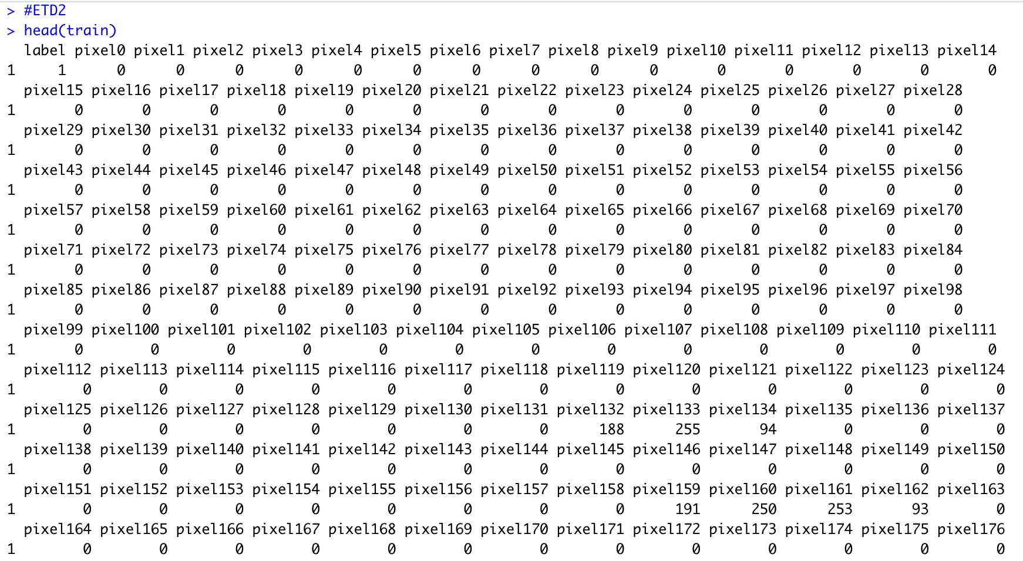

**Figure 16: head(train)**

**Str(train):**

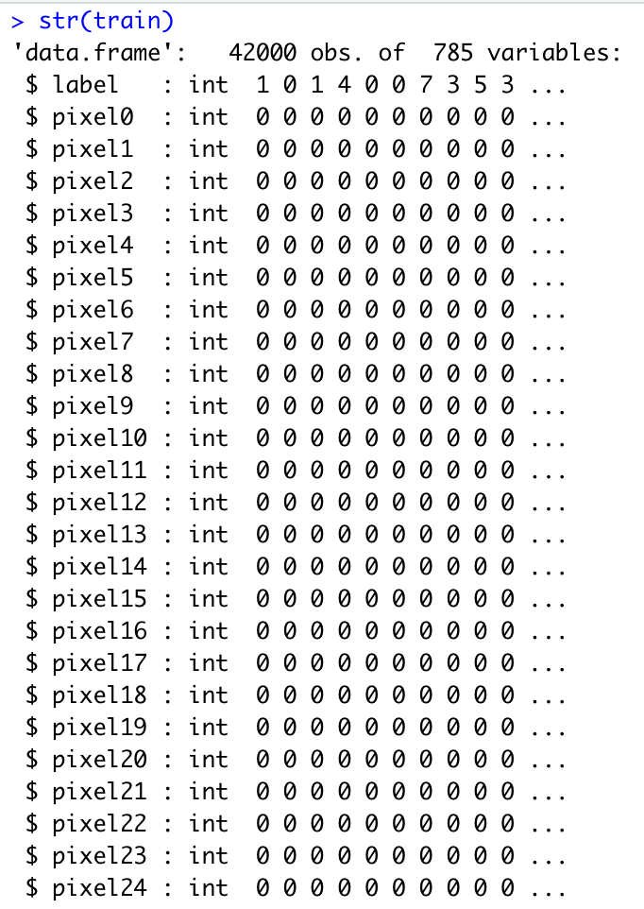

**Figure 17: str(train)**

**Head(test)**

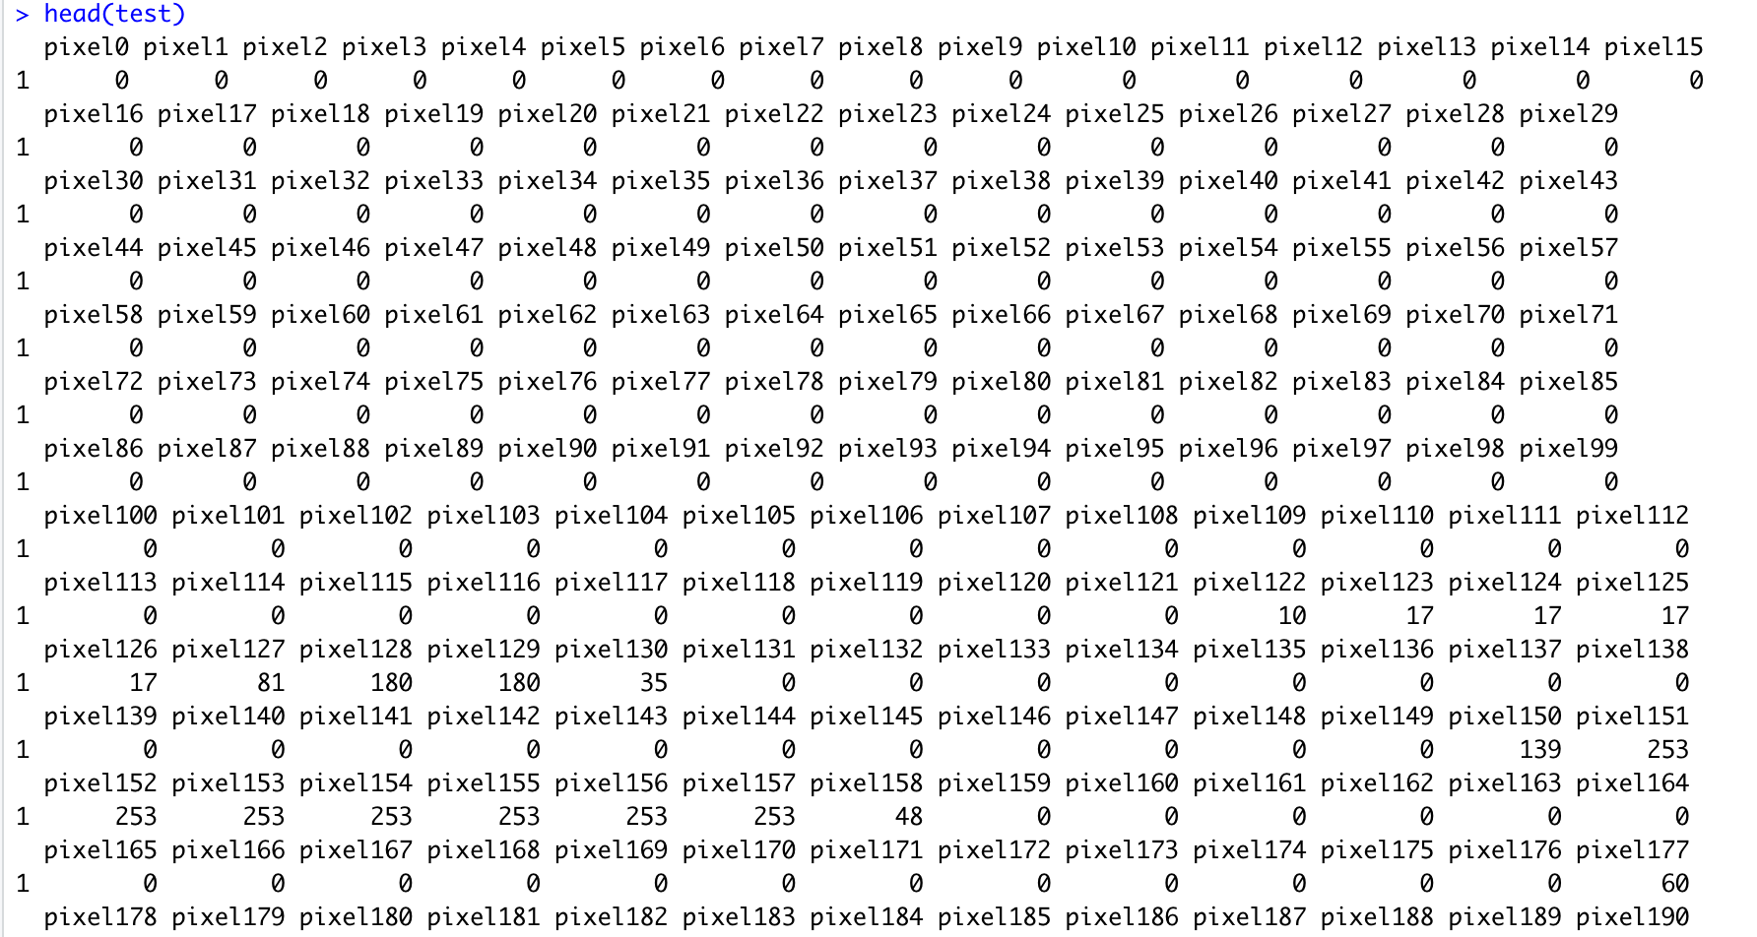

**Figure 18: head(test)**

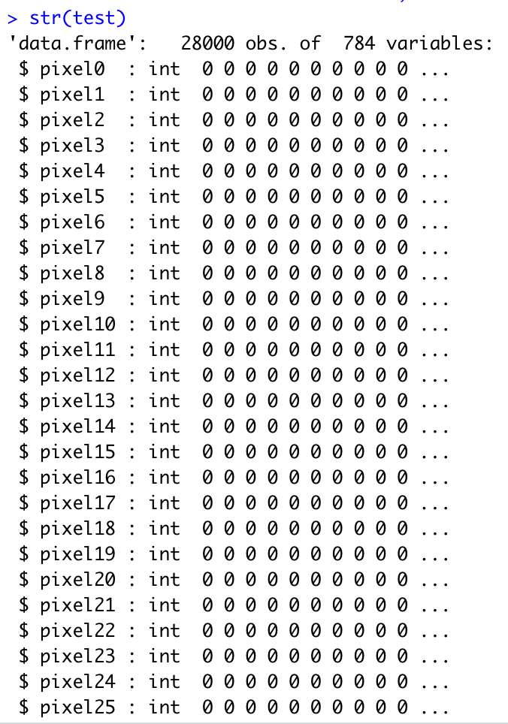

**Figure 19: str(test)**

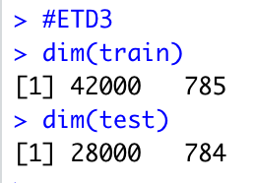

**Figure 20: dim(train) and din(test)**

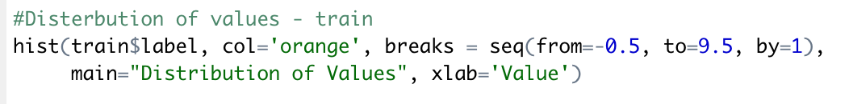

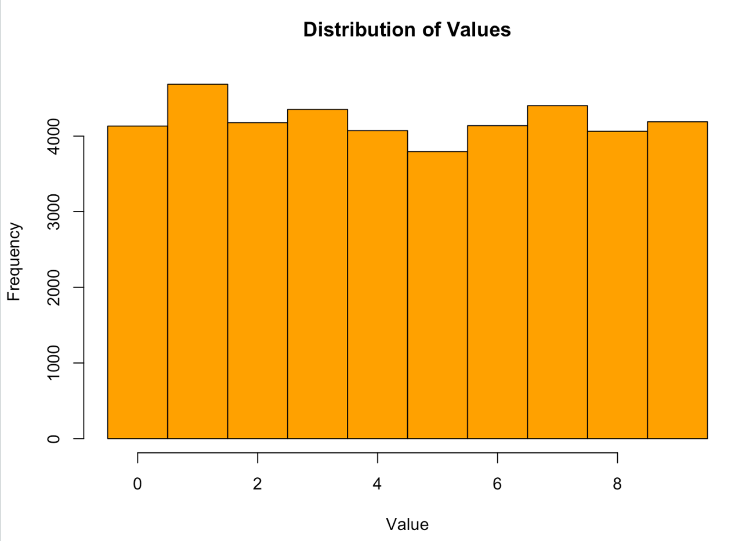

**Figure 21: Plotting the matrix (train): distribution of values**

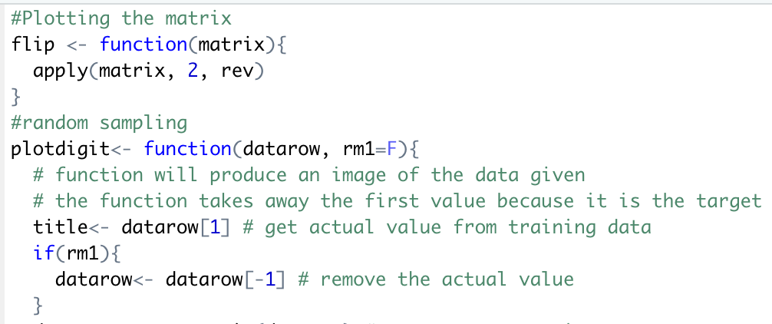

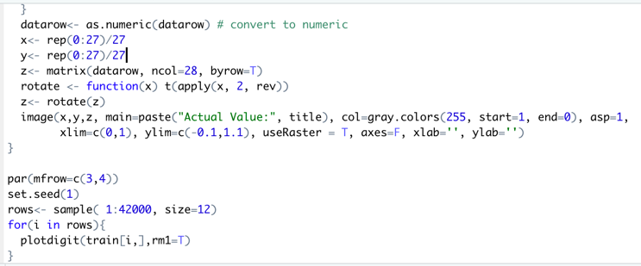

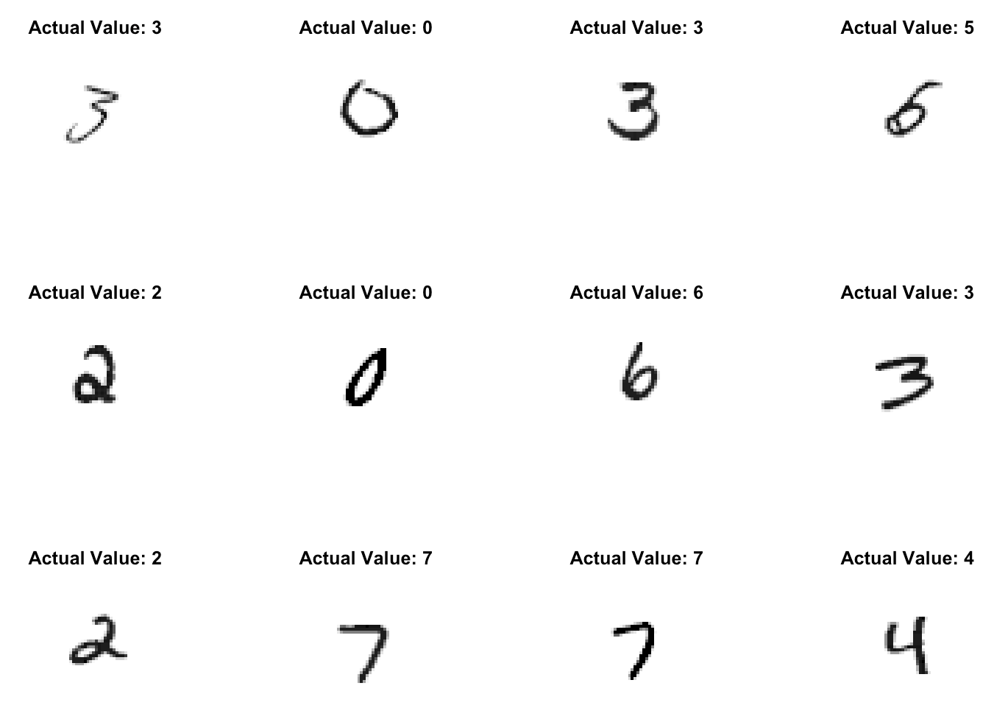

**Figure 22: Plotting the matrix (train): random sampling**

# Data Transformation and Cleansing

# Creating Samples

Creating samples for training and testing datasets as follows:

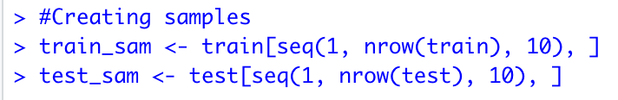

**Figure 23: Creating Samples**

# Removing pixels that have 0 in all images

In this step, we are about to remove all pixels that have 0 in all images.



**Figure 24: Removing pixels that have 0 in all images**

# Removing pixels with low variance

Here we are removing pixels with low variance as follows:

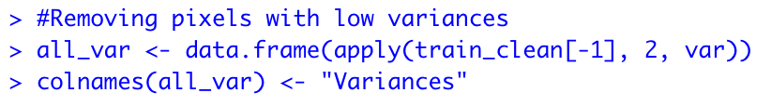

**Figure 25: Removing pixels with low variance**

# Sorting variance and creating number labels for variance Incl. summary of all variance

Sorting variance and creating number labels for variance:

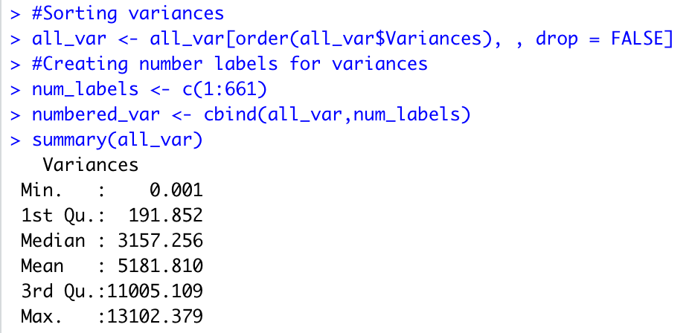

**Figure 26: Sorting variance and creating number labels for variance Incl. summary of all variance**

# Plotting all variances

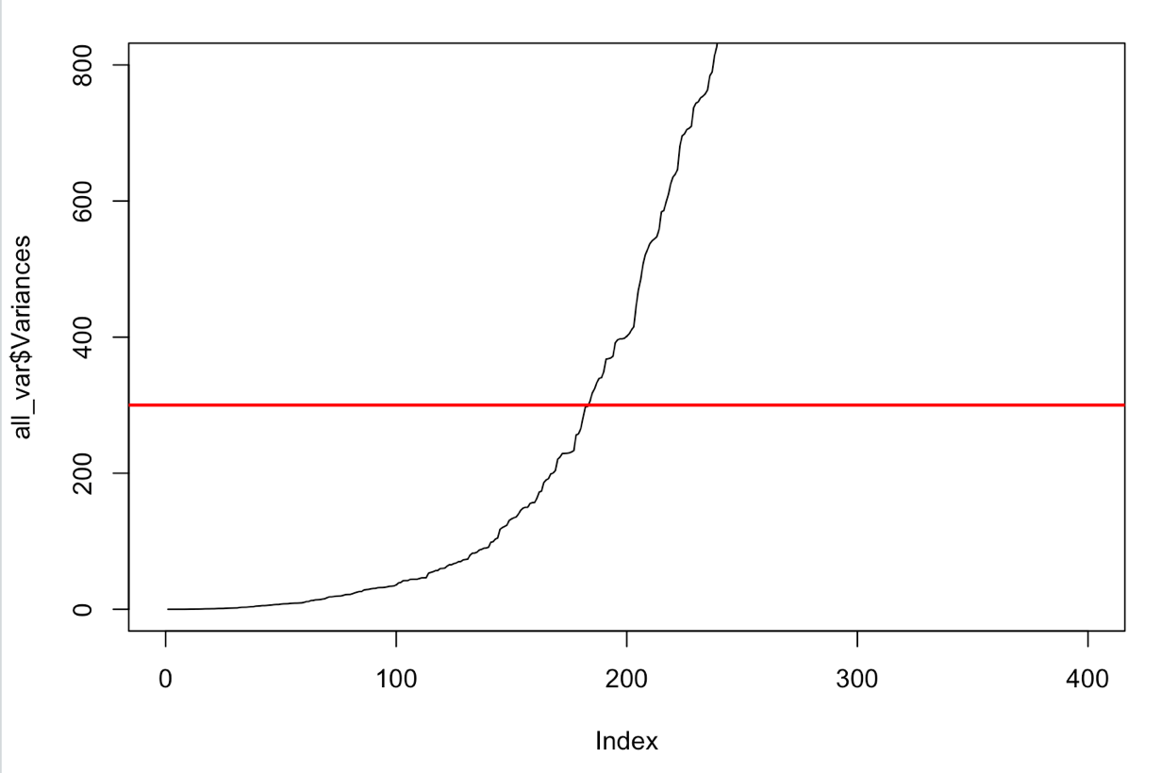

**Figure 27: Plotting all variances**

# Creating clean train set with good variance

In this step, we are creating clean trainset with good variance:

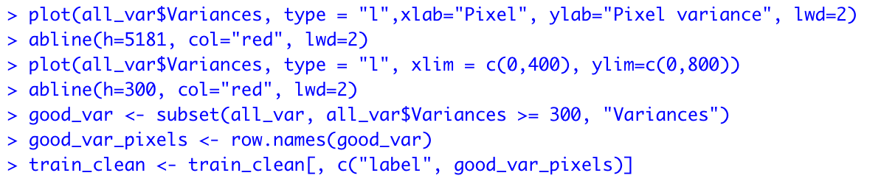

**Figure 28: Creating clean train set with good variance**

# Normalizing the data

Normalizing the data:

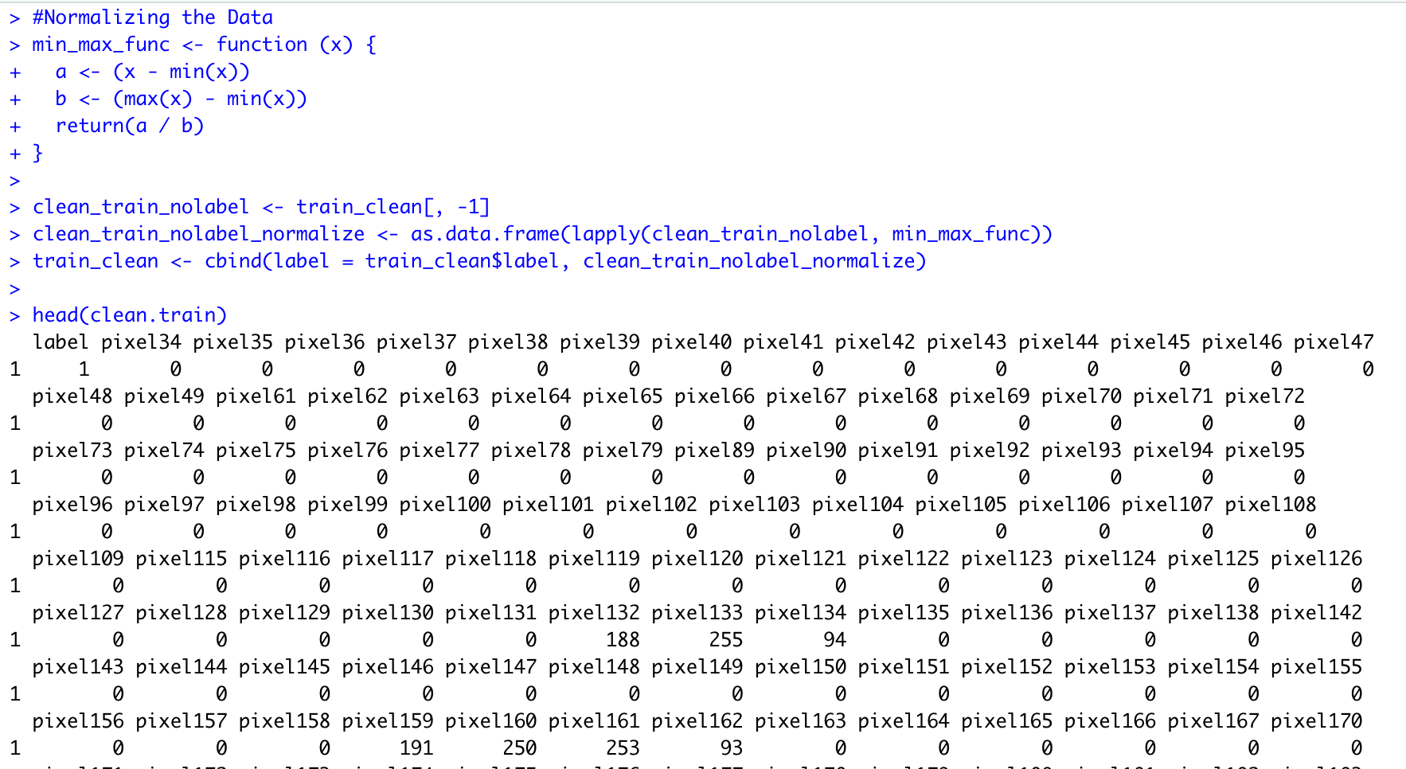

**Figure 29: Normalizing the data**

# Creating Test and Train sets for the Training Data Set

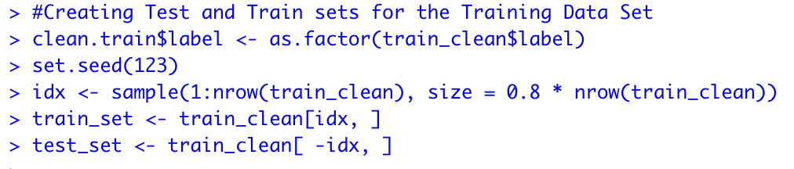

**Figure 30: Creating test and train sets for the training data set**

# kNN, Random Forest and SVM (Part II)

# Building the kNN Model – Train and testing sets

Now, we are stating the build the different models and we will start with kNN as follows:

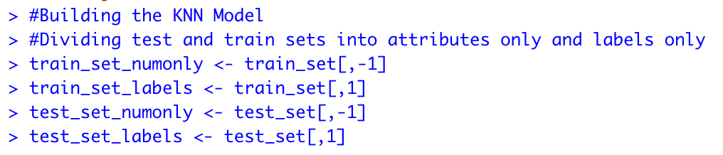

**Figure 31: Building the kNN model**

# kNN - Choosing the K and Building the model

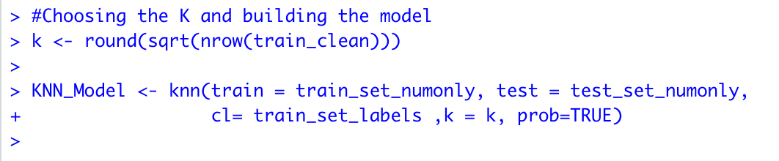

**Figure 32: Choosing the K and Building the Model**

# kNN - Confusion Matrix and Accuracy

The kNN model received 82.86%

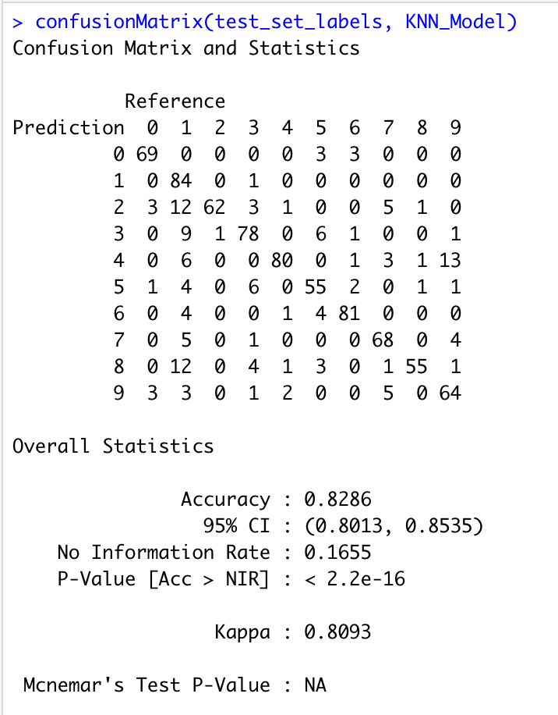

**Figure 32: kNN confusion matrix**

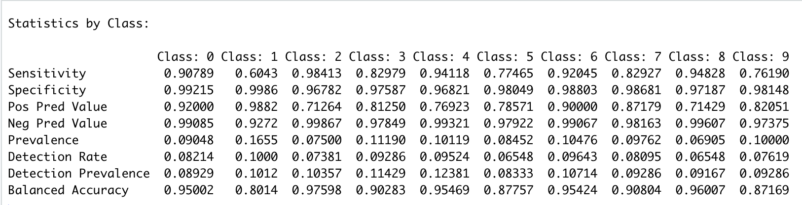

**Figure 33: kNN statistics by Class**

# Random Forest – Building the Random Forest Model

Building the Random Forest Model:

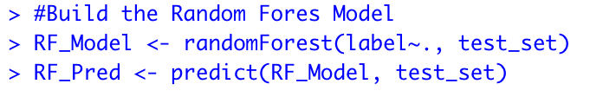

**Figure 34: Building the Random Forest Model**

# Random Forest – Confusion Matrix and Accuracy

Random Forest received 99.56% accuracy.

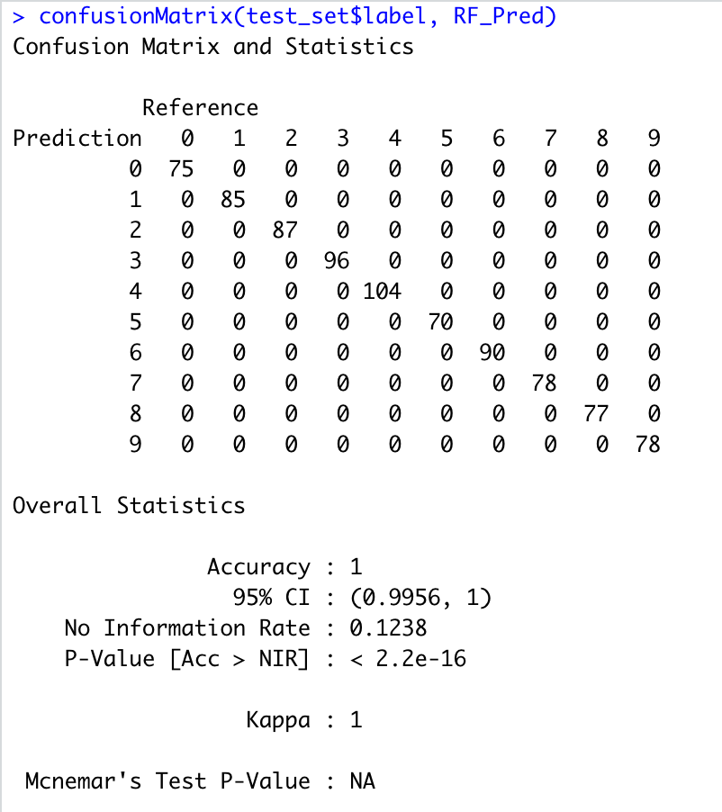

**Figure 34: Random Forest Confusion Matrix**

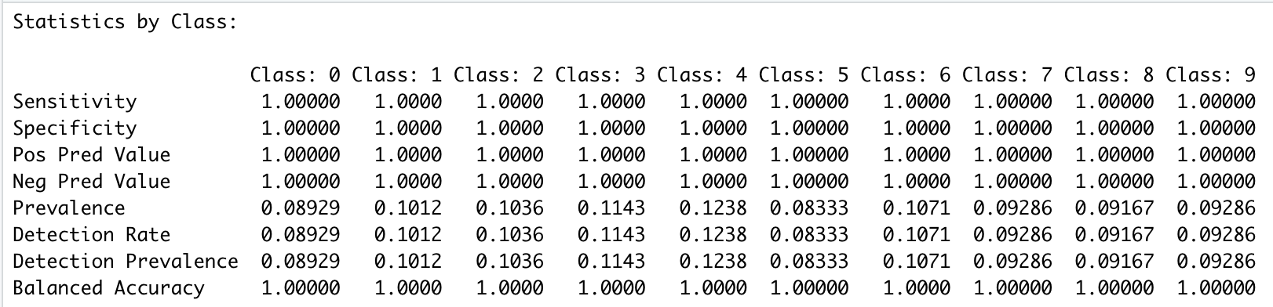

**Figure 35: RF statistics by Class**

# Plotting RF Model

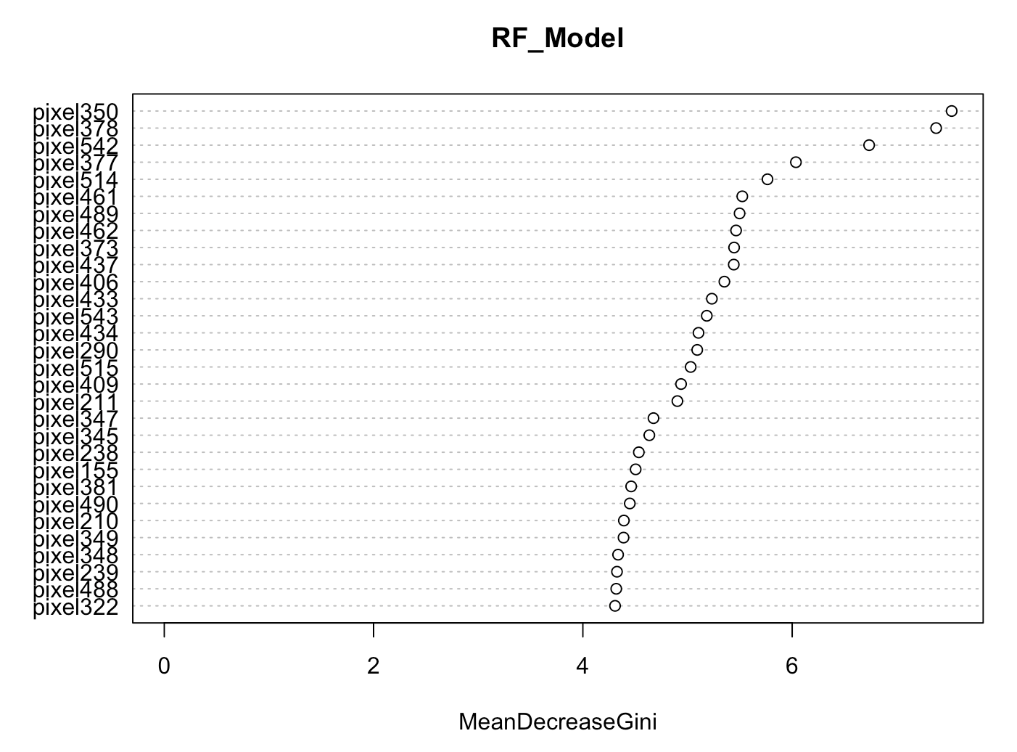

**Figure 36: RF Model**

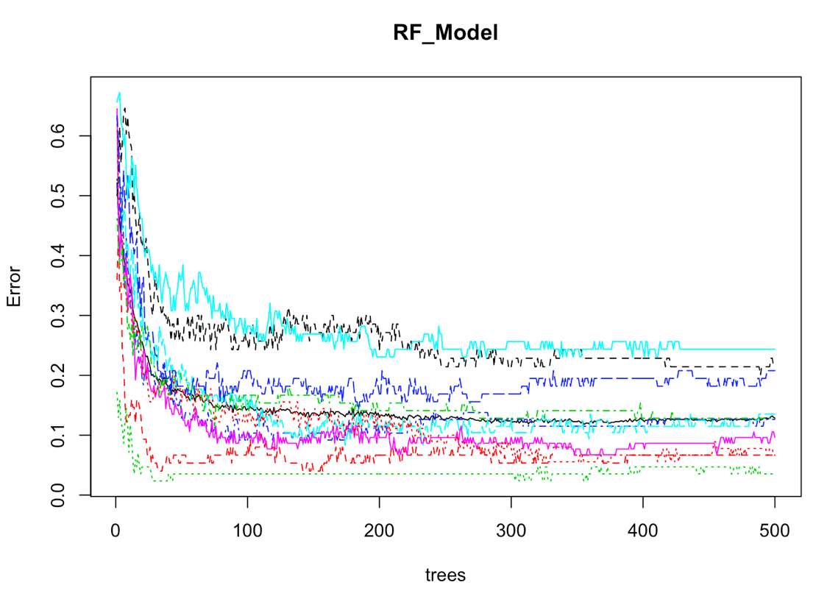

**Figure 37: RF Model by trees and Errors**

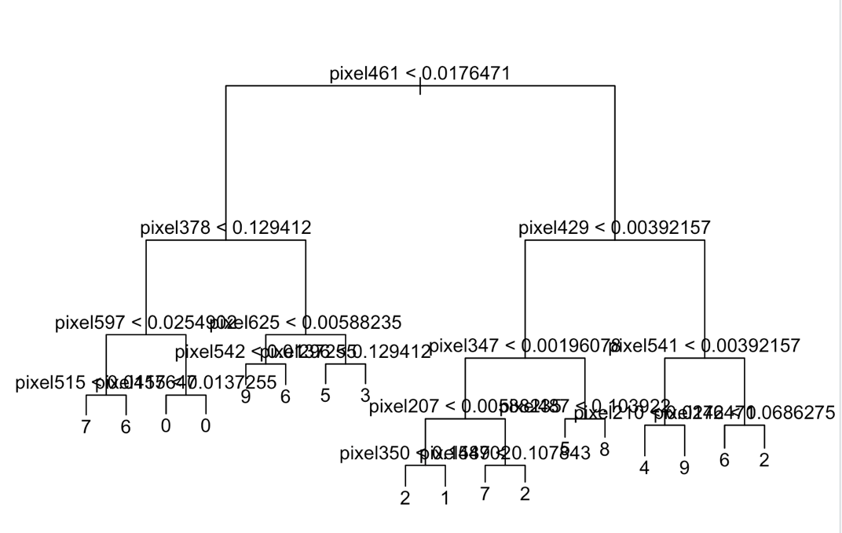

**Figure 38: RF Model trees**

# SVM Model – Building the Model

Building the SVM Model:

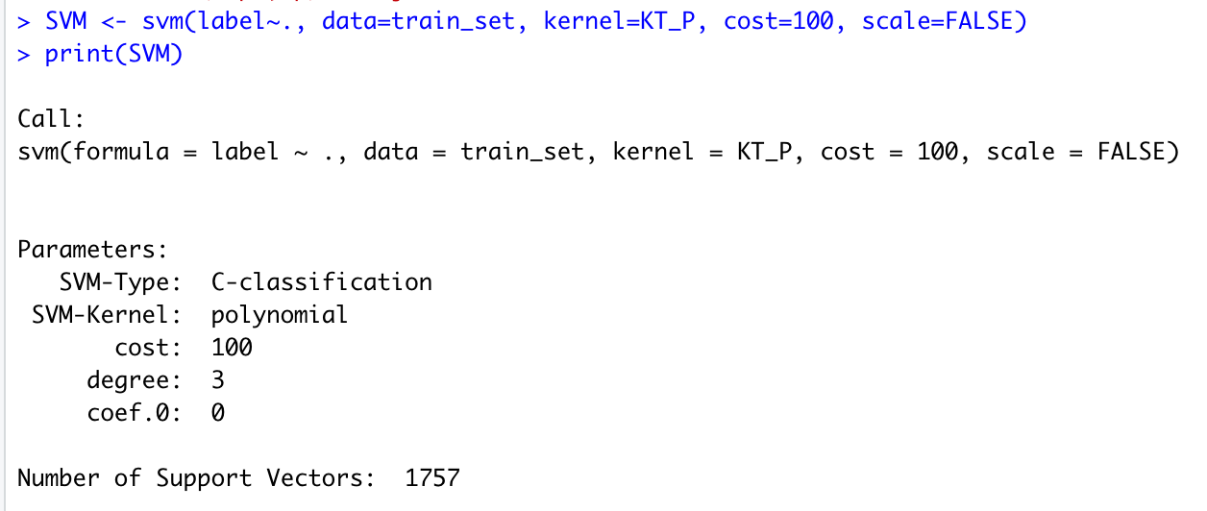

**Figure 39: Building the SVM Model**

# SVM Model – Predication



**Figure 40: SVM Predication**

# SVM Model – Confusion Matrix and Accuracy

Accuracy received: 88.45%

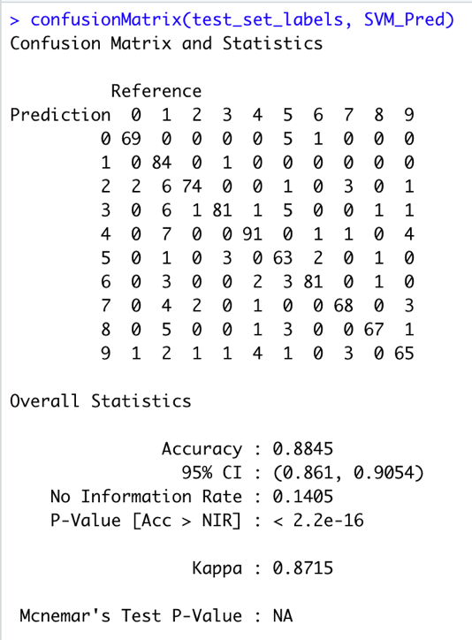

**Figure 41: SVM Confusion Matrix**

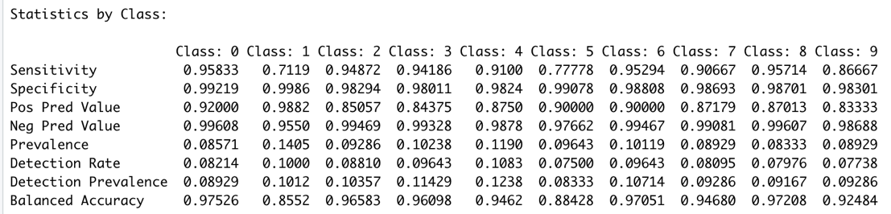

**Figure 42: SVM Statistics by Class**

# Naïve Bayes – Building the Model

Building the Naïve Bayes model:

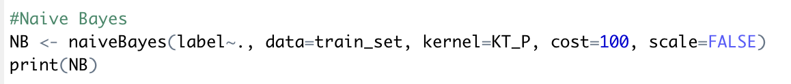

**Y [,1] [,2]**

**0 0.11892044 0.2817960**

**1 0.64252701 0.4000161**

**2 0.66419118 0.4039180**

**3 0.08823529 0.2491862**

**4 0.46038312 0.4208039**

**5 0.21024668 0.3603020**

**6 0.49451754 0.4330077**

**7 0.60633134 0.4152582**

**8 0.37776212 0.4162964**

**9 0.37196805 0.4119040**

**pixel352**

**Y [,1] [,2]**

**0 0.04384719 0.1616616**

**1 0.52769108 0.4070160**

**2 0.45518382 0.4376923**

**3 0.70401494 0.3846749**

**4 0.47412556 0.4211176**

**5 0.27997470 0.3998559**

**6 0.29815531 0.3997760**

**7 0.42763285 0.4199880**

**8 0.65270635 0.3903785**

**9 0.58194142 0.4121841**

**pixel210**

**Y [,1] [,2]**

**0 0.7275073 0.3694106**

**1 0.3905462 0.4383860**

**2 0.4683333 0.4380928**

**3 0.6055322 0.4147567**

**4 0.1564220 0.3186634**

**5 0.5986211 0.4280781**

**6 0.4657379 0.4330869**

**7 0.4535038 0.4148618**

**8 0.6039216 0.3997403**

**9 0.7441298 0.3237961**

**pixel521**

**Y [,1] [,2]**

**0 0.45165652 0.4404825**

**1 0.03355342 0.1550239**

**2 0.55224265 0.4323362**

**3 0.44283380 0.4336549**

**4 0.43068317 0.4249618**

**5 0.43638204 0.4364089**

**6 0.60900413 0.4083187**

**7 0.36289855 0.4125371**

**8 0.40328754 0.4378859**

**9 0.49450496 0.4314044**

**pixel408**

**Y [,1] [,2]**

**0 0.01836827 0.09960667**

**1 0.26699680 0.34012204**

**2 0.58264706 0.42551753**

**3 0.59595005 0.41908367**

**4 0.76167712 0.34854918**

**5 0.44412397 0.43370559**

**6 0.61333849 0.41385313**

**7 0.63893151 0.40980911**

**8 0.69311964 0.37872049**

**9 0.79011135 0.32219749**

**pixel380**

**Y [,1] [,2]**

**0 0.02174893 0.1189441**

**1 0.41546619 0.3834960**

**2 0.52295343 0.4328291**

**3 0.69942810 0.3939619**

**4 0.61930271 0.4135442**

**5 0.38885515 0.4251007**

**6 0.49218266 0.4399053**

**7 0.52393294 0.4315859**

**8 0.72485617 0.3571277**

**9 0.72409828 0.3747768**

**pixel657**

**Y [,1] [,2]**

**0 0.55670498 0.4093116**

**1 0.30038015 0.3911367**

**2 0.10120098 0.2635586**

**3 0.67843137 0.3929199**

**4 0.25350059 0.3706419**

**5 0.56455408 0.4407969**

**6 0.01324819 0.1020448**

**7 0.46878090 0.4410443**

**8 0.72877774 0.3515610**

**9 0.32833454 0.4056471**

**pixel240**

**Y [,1] [,2]**

**0 0.5771242 0.4228047**

**1 0.5745698 0.4272598**

**2 0.4384926 0.4316941**

**3 0.5697362 0.4131880**

**4 0.2163870 0.3614388**

**5 0.4383428 0.4258330**

**6 0.2024123 0.3557413**

**7 0.7097926 0.3751072**

**8 0.3762710 0.4095520**

**9 0.6801017 0.3708195**

**pixel598**

**Y [,1] [,2]**

**0 0.77740590 0.3327586**

**1 0.34742897 0.4337444**

**2 0.64814951 0.4176493**

**3 0.44953315 0.4302004**

**4 0.07802452 0.2399204**

**5 0.50943707 0.4264198**

**6 0.42567079 0.4077993**

**7 0.16858198 0.3367288**

**8 0.55000587 0.4057598**

**9 0.06872428 0.2252449**

**pixel545**

**Y [,1] [,2]**

**0 0.21548343 0.3567772**

**1 0.67551020 0.3891298**

**2 0.67495098 0.3948082**

**3 0.09597339 0.2537450**

**4 0.29744024 0.4002326**

**5 0.20631246 0.3587605**

**6 0.69484004 0.3926409**

**7 0.46741688 0.4348248**

**8 0.30942820 0.3965972**

**9 0.24065602 0.3809296**

**pixel213**

**Y [,1] [,2]**

**0 0.7180077 0.3724686**

**1 0.4491697 0.4416003**

**2 0.5598775 0.4203353**

**3 0.6160714 0.4161937**

**4 0.3065265 0.4057293**

**5 0.5344972 0.4316871**

**6 0.1653380 0.3281919**

**7 0.4202444 0.4230280**

**8 0.5955266 0.4054251**

**9 0.5985355 0.4112060**

**pixel520**

**Y [,1] [,2]**

**0 0.3108519 0.4118483**

**1 0.1104242 0.2653328**

**2 0.6085294 0.4152034**

**3 0.3012722 0.3973312**

**4 0.5860315 0.4258282**

**5 0.3817963 0.4203928**

**6 0.5231037 0.4236679**

**7 0.5914635 0.4128268**

**8 0.4410825 0.4220692**

**9 0.6237110 0.4020479**

**pixel351**

**Y [,1] [,2]**

**0 0.04894073 0.1844142**

**1 0.86352541 0.2590397**

**2 0.32840686 0.4148788**

**3 0.75246265 0.3486674**

**4 0.23950952 0.3567238**

**5 0.34161923 0.4136230**

**6 0.23264964 0.3588468**

**7 0.19616937 0.3356522**

**8 0.57443936 0.4155485**

**9 0.37636166 0.4128662**

**pixel235**

**Y [,1] [,2]**

**0 0.59637142 0.4217146**

**1 0.03103241 0.1420803**

**2 0.31609069 0.4172427**

**3 0.34126984 0.4039118**

**4 0.33259875 0.4004994**

**5 0.45340923 0.4293379**

**6 0.41429309 0.4353753**

**7 0.67006536 0.3987671**

**8 0.58088529 0.4177791**

**9 0.67006778 0.3793795**

**pixel548**

**Y [,1] [,2]**

**0 0.4880550 0.4421342**

**1 0.1214886 0.2820120**

**2 0.5773652 0.4259893**

**3 0.4209734 0.4317038**

**4 0.4761485 0.4329153**

**5 0.4258318 0.4249483**

**6 0.7046053 0.3784591**

**7 0.4572890 0.4265720**

**8 0.4463544 0.4211924**

**9 0.5424837 0.4204101**

**pixel577**

**Y [,1] [,2]**

**0 0.67134325 0.3921455**

**1 0.04712885 0.1859942**

**2 0.47622549 0.4352034**

**3 0.62226891 0.3988556**

**4 0.29239984 0.3991912**

**5 0.49373814 0.4399908**

**6 0.65158669 0.3921229**

**7 0.16736573 0.3256596**

**8 0.44570858 0.4330508**

**9 0.35048414 0.4124193**

**pixel549**

**Y [,1] [,2]**

**0 0.60215236 0.4217234**

**1 0.03778511 0.1562665**

**2 0.54561275 0.4201442**

**3 0.52783613 0.4199748**

**4 0.34697406 0.4223525**

**5 0.46040481 0.4401412**

**6 0.72107843 0.3632188**

**7 0.24180733 0.3622213**

**8 0.42507925 0.4365448**

**9 0.41909949 0.4262781**

**pixel291**

**Y [,1] [,2]**

**0 0.65105927 0.4090329**

**1 0.02185874 0.1216729**

**2 0.11976716 0.2865726**

**3 0.14124650 0.2955524**

**4 0.44989546 0.4290367**

**5 0.55528147 0.4219112**

**6 0.52699948 0.4320706**

**7 0.52564933 0.4340002**

**8 0.56498767 0.4191112**

**9 0.58270395 0.4145422**

**pixel604**

**Y [,1] [,2]**

**0 0.6822853 0.3786055**

**1 0.1500200 0.3113679**

**2 0.3378554 0.4237009**

**3 0.6808007 0.3777618**

**4 0.3439905 0.4208890**

**5 0.5632764 0.4303668**

**6 0.5392157 0.4016889**

**7 0.2595851 0.3863432**

**8 0.5168369 0.4278655**

**9 0.4001573 0.4280979**

**pixel599**

**Y [,1] [,2]**

**0 0.7260536 0.3688003**

**1 0.4666867 0.4393243**

**2 0.6100613 0.4207528**

**3 0.4520075 0.4257325**

**4 0.1461378 0.3134431**

**5 0.5205566 0.4265433**

**6 0.5863132 0.3981621**

**7 0.2845240 0.3991354**

**8 0.5274862 0.4188696**

**9 0.1377875 0.3095805**

**pixel576**

**Y [,1] [,2]**

**0 0.6441740 0.4040629**

**1 0.1344038 0.2954014**

**2 0.4867525 0.4363631**

**3 0.5768207 0.4170223**

**4 0.3919308 0.4180672**

**5 0.4918659 0.4349062**

**6 0.7674923 0.3237915**

**7 0.3389031 0.4075167**

**8 0.4760127 0.4276318**

**9 0.4612443 0.4338905**

**pixel574**

**Y [,1] [,2]**

**0 0.4900270 0.4392895**

**1 0.4696979 0.4404518**

**2 0.5344730 0.4310737**

**3 0.3503852 0.4139130**

**4 0.4087359 0.4220349**

**5 0.3936496 0.4174786**

**6 0.8403767 0.2870555**

**7 0.6296903 0.4142169**

**8 0.3616414 0.4080600**

**9 0.4345195 0.4344534**

**pixel489**

**Y [,1] [,2]**

**0 0.02423935 0.1156079**

**1 0.84108643 0.2737123**

**2 0.69712010 0.3882885**

**3 0.07658730 0.2357523**

**4 0.42562016 0.4194603**

**5 0.14031626 0.3007461**

**6 0.52444530 0.4223542**

**7 0.28519466 0.3944461**

**8 0.56894446 0.4295545**

**9 0.31637618 0.3981589**

**pixel465**

**Y [,1] [,2]**

**0 0.17971602 0.33252215**

**1 0.01592637 0.08304341**

**2 0.47763480 0.44436504**

**3 0.47450980 0.42632910**

**4 0.73372888 0.35879795**

**5 0.41934219 0.42584039**

**6 0.42403251 0.42354535**

**7 0.62250639 0.40904562**

**8 0.38971469 0.41582759**

**9 0.70525297 0.37141553**

**pixel354**

**Y [,1] [,2]**

**0 0.18181204 0.3346291**

**1 0.05211084 0.1958246**

**2 0.48268382 0.4322539**

**3 0.36539449 0.4149537**

**4 0.64694581 0.3972606**

**5 0.15311828 0.3126744**

**6 0.33426213 0.4147653**

**7 0.68475135 0.3788130**

**8 0.54271457 0.4239719**

**9 0.69885016 0.3875648**

**pixel241**

**Y [,1] [,2]**

**0 0.58777327 0.4251416**

**1 0.44341737 0.4394661**

**2 0.51096814 0.4299318**

**3 0.58552754 0.4280611**

**4 0.35825281 0.4215903**

**5 0.41757116 0.4320697**

**6 0.09183437 0.2427976**

**7 0.68613811 0.3883681**

**8 0.45436186 0.4202763**

**9 0.63298233 0.3947220**

**pixel214**

**Y [,1] [,2]**

**0 0.72928781 0.3759077**

**1 0.32024810 0.4229124**

**2 0.52074755 0.4365497**

**3 0.49543651 0.4346628**

**4 0.37193875 0.4295948**

**5 0.47547122 0.4310502**

**6 0.08560372 0.2371624**

**7 0.35760159 0.4099512**

**8 0.62837854 0.3964049**

**9 0.43248608 0.4206628**

**pixel353**

**Y [,1] [,2]**

**0 0.07195177 0.2129966**

**1 0.16953782 0.3018265**

**2 0.53910539 0.4226642**

**3 0.56245331 0.4113599**

**4 0.65959202 0.3890470**

**5 0.22308665 0.3723910**

**6 0.33526832 0.4203950**

**7 0.63627167 0.4020508**

**8 0.64636609 0.3900742**

**9 0.73671024 0.3588891**

**pixel290**

**Y [,1] [,2]**

**0 0.647960334 0.40229301**

**1 0.007833133 0.08284056**

**2 0.136164216 0.30358546**

**3 0.104586835 0.26120967**

**4 0.483144036 0.42293773**

**5 0.521366224 0.42488620**

**6 0.455392157 0.43237250**

**7 0.541847116 0.43228776**

**8 0.543313373 0.42440731**

**9 0.678915517 0.37423906**

**pixel264**

**Y [,1] [,2]**

**0 0.6604012 0.4135513**

**1 0.1094038 0.2768623**

**2 0.2044240 0.3552141**

**3 0.1818394 0.3283483**

**4 0.3568740 0.4222409**

**5 0.5258697 0.4344890**

**6 0.5094298 0.4335451**

**7 0.7045524 0.3744396**

**8 0.5037807 0.4239564**

**9 0.6348100 0.3885224**

**pixel572**

**Y [,1] [,2]**

**0 0.4228307 0.4176163**

**1 0.5736695 0.4234653**

**2 0.6587623 0.3951862**

**3 0.1982376 0.3349886**

**4 0.2029610 0.3594468**

**5 0.3047944 0.3997454**

**6 0.8438080 0.2912909**

**7 0.3677067 0.4264788**

**8 0.3774921 0.4188011**

**9 0.1721859 0.3422132**

**pixel626**

**Y [,1] [,2]**

**0 0.77053189 0.3341296**

**1 0.35169068 0.4329239**

**2 0.45269608 0.4360547**

**3 0.63879552 0.4051916**

**4 0.09895463 0.2637450**

**5 0.56075901 0.4161626**

**6 0.10819143 0.2675506**

**7 0.23336175 0.3829288**

**8 0.58852882 0.4163461**

**9 0.11778020 0.2878692**

**pixel239**

**Y [,1] [,2]**

**0 0.5809331 0.4274428**

**1 0.6015906 0.4209028**

**2 0.3775245 0.4179784**

**3 0.4794935 0.4163996**

**4 0.1430525 0.3056457**

**5 0.4593548 0.4314347**

**6 0.3153380 0.4139308**

**7 0.7268542 0.3729720**

**8 0.3787719 0.4198304**

**9 0.6864803 0.3797023**

**pixel603**

**Y [,1] [,2]**

**0 0.7181542 0.3702359**

**1 0.2786615 0.4119792**

**2 0.3520466 0.4221484**

**3 0.6606209 0.3898614**

**4 0.3799966 0.4282088**

**5 0.5586464 0.4263935**

**6 0.6721104 0.3731844**

**7 0.4343620 0.4319548**

**8 0.5217330 0.4255577**

**9 0.4486807 0.4409716**

**pixel573**

**Y [,1] [,2]**

**0 0.4353505 0.4349335**

**1 0.5914866 0.4178415**

**2 0.6021936 0.4184444**

**3 0.2488912 0.3641740**

**4 0.3206871 0.4072765**

**5 0.3330803 0.4047520**

**6 0.8377580 0.2953651**

**7 0.5279113 0.4349359**

**8 0.3210872 0.3933801**

**9 0.2788429 0.4046373**

**pixel656**

**Y [,1] [,2]**

**0 0.59861393 0.4056733**

**1 0.35670268 0.4138773**

**2 0.13099265 0.2929504**

**3 0.69216853 0.3753573**

**4 0.21392326 0.3667675**

**5 0.57620493 0.4288355**

**6 0.01348039 0.1080395**

**7 0.47065644 0.4390745**

**8 0.72902430 0.3445163**

**9 0.27961753 0.4091561**

**pixel547**

**Y [,1] [,2]**

**0 0.3646383 0.4269047**

**1 0.3030212 0.4131211**

**2 0.6026961 0.4183638**

**3 0.2728058 0.3856663**

**4 0.5075210 0.4373287**

**5 0.3437571 0.3980416**

**6 0.6708075 0.3949051**

**7 0.6452174 0.4146176**

**8 0.3934367 0.4288257**

**9 0.5449770 0.4269111**

**pixel546**

**Y [,1] [,2]**

**0 0.2686049 0.3910686**

**1 0.5440676 0.4260860**

**2 0.6386887 0.4146480**

**3 0.1547502 0.3107776**

**4 0.4448890 0.4319171**

**5 0.2594687 0.3925925**

**6 0.6615712 0.3963387**

**7 0.6409321 0.4075362**

**8 0.3221087 0.4085676**

**9 0.4065359 0.4298948**

**pixel270**

**Y [,1] [,2]**

**0 0.49043272 0.4320667**

**1 0.23661465 0.3776119**

**2 0.50980392 0.4247456**

**3 0.48125584 0.4311544**

**4 0.50157654 0.4298861**

**5 0.24651486 0.3830161**

**6 0.03583591 0.1607071**

**7 0.74641660 0.3707887**

**8 0.53457790 0.4152490**

**9 0.55313483 0.4134075**

**pixel381**

**Y [,1] [,2]**

**0 0.05353843 0.1935037**

**1 0.09497799 0.2341751**

**2 0.55263480 0.4205599**

**3 0.59815593 0.4083612**

**4 0.73277957 0.3482985**

**5 0.32475648 0.4086179**

**6 0.52573529 0.4277660**

**7 0.68707019 0.3876696**

**8 0.58849360 0.4062141**

**9 0.80359477 0.3199293**

**pixel631**

**Y [,1] [,2]**

**0 0.6319135 0.3890084**

**1 0.2606543 0.4008943**

**2 0.1936887 0.3487374**

**3 0.6940243 0.3799641**

**4 0.3391422 0.4209874**

**5 0.5956736 0.4239436**

**6 0.2108359 0.3492185**

**7 0.3613413 0.4137631**

**8 0.5936245 0.4168433**

**9 0.4025781 0.4430821**

**pixel263**

**Y [,1] [,2]**

**0 0.66915709 0.3987229**

**1 0.02810124 0.1410171**

**2 0.21671569 0.3733765**

**3 0.16642157 0.3184569**

**4 0.40683732 0.4085814**

**5 0.51614168 0.4342895**

**6 0.47494840 0.4304935**

**7 0.70567775 0.3696661**

**8 0.57891276 0.4184796**

**9 0.71526265 0.3495803**

**pixel382**

**Y [,1] [,2]**

**0 0.1628240 0.3245262**

**1 0.0207583 0.1111265**

**2 0.4662255 0.4389090**

**3 0.4310341 0.4257303**

**4 0.6592756 0.4011239**

**5 0.2377483 0.3712757**

**6 0.5233101 0.4331355**

**7 0.6684513 0.3895512**

**8 0.4055066 0.4125426**

**9 0.6937182 0.3949751**

**pixel236**

**Y [,1] [,2]**

**0 0.6800992 0.3959198**

**1 0.1089536 0.2792813**

**2 0.3131373 0.4164193**

**3 0.3273693 0.3997144**

**4 0.2968639 0.3927035**

**5 0.5138899 0.4310883**

**6 0.4856553 0.4347223**

**7 0.6991645 0.3815343**

**8 0.5841376 0.4140828**

**9 0.7626604 0.3222479**

**pixel463**

**Y [,1] [,2]**

**0 0.03477575 0.1513037**

**1 0.51926771 0.3888435**

**2 0.64340686 0.4167415**

**3 0.24169001 0.3724342**

**4 0.79401028 0.3166405**

**5 0.32417457 0.4033772**

**6 0.51096491 0.4292391**

**7 0.64553566 0.4121011**

**8 0.61280967 0.4139600**

**9 0.62952070 0.4059175**

**pixel519**

**Y [,1] [,2]**

**0 0.1846405 0.3410472**

**1 0.3363846 0.4134859**

**2 0.6501716 0.4133989**

**3 0.1636788 0.3249215**

**4 0.6003051 0.4157899**

**5 0.3004048 0.4108068**

**6 0.4768189 0.4248877**

**7 0.7084854 0.3919810**

**8 0.4221322 0.4235146**

**9 0.5681554 0.4205545**

**pixel575**

**Y [,1] [,2]**

**0 0.5772143 0.4303806**

**1 0.2872949 0.4183411**

**2 0.5012623 0.4355866**

**3 0.4658263 0.4451923**

**4 0.4386958 0.4399147**

**5 0.4633650 0.4323179**

**6 0.8356424 0.2789395**

**7 0.5438250 0.4234693**

**8 0.4506047 0.4326909**

**9 0.5005810 0.4304774**

**pixel629**

**Y [,1] [,2]**

**0 0.7690331 0.3449407**

**1 0.4154162 0.4274387**

**2 0.2865809 0.3999310**

**3 0.7290850 0.3645984**

**4 0.2977793 0.3962586**

**5 0.6573308 0.3997621**

**6 0.2726909 0.3890080**

**7 0.5232396 0.4288137**

**8 0.6863215 0.3728091**

**9 0.3381748 0.4155650**

**pixel181**

**Y [,1] [,2]**

**0 0.6074037 0.4083677**

**1 0.2176771 0.3710131**

**2 0.5919240 0.4234807**

**3 0.7408847 0.3656070**

**4 0.1272193 0.2850643**

**5 0.4713725 0.4328166**

**6 0.4450464 0.4407826**

**7 0.1263200 0.2888853**

**8 0.6538218 0.4089072**

**9 0.2863229 0.3732097**

**pixel492**

**Y [,1] [,2]**

**0 0.1603448 0.3201406**

**1 0.1084634 0.2538034**

**2 0.5828309 0.4432236**

**3 0.2542017 0.3720104**

**4 0.7373227 0.3588288**

**5 0.3566856 0.4179339**

**6 0.4127709 0.4254329**

**7 0.7055527 0.3732081**

**8 0.4561465 0.4292955**

**9 0.7048656 0.3723897**

**pixel238**

**Y [,1] [,2]**

**0 0.6382466 0.4139296**

**1 0.4441677 0.4378873**

**2 0.3208701 0.4072276**

**3 0.3901027 0.4167842**

**4 0.1701531 0.3338896**

**5 0.5152435 0.4296424**

**6 0.4307147 0.4328271**

**7 0.7289798 0.3731411**

**8 0.4127627 0.4236859**

**9 0.7191237 0.3750278**

**pixel242**

**Y [,1] [,2]**

**0 0.63505747 0.4048933**

**1 0.28866547 0.4104528**

**2 0.51797794 0.4245751**

**3 0.50435341 0.4337948**

**4 0.44213143 0.4294940**

**5 0.37781151 0.4271598**

**6 0.03973168 0.1754769**

**7 0.63205456 0.4211641**

**8 0.55636961 0.4213677**

**9 0.54163641 0.4148043**

**pixel410**

**Y [,1] [,2]**

**0 0.184099617 0.34830327**

**1 0.003841537 0.03277532**

**2 0.421789216 0.44269589**

**3 0.531594304 0.43385938**

**4 0.681968695 0.39170997**

**5 0.344313725 0.40968952**

**6 0.607636739 0.42930889**

**7 0.614992896 0.40424707**

**8 0.279523306 0.38352745**

**9 0.634507383 0.40316794**

**pixel405**

**Y [,1] [,2]**

**0 0.03887762 0.1624713**

**1 0.75570228 0.2961414**

**2 0.43712010 0.4372352**

**3 0.61663165 0.4184568**

**4 0.43761089 0.4265884**

**5 0.54622391 0.4247115**

**6 0.41124871 0.4303518**

**7 0.05150327 0.1923068**

**8 0.82207350 0.2907942**

**9 0.50273542 0.4210004**

**pixel436**

**Y [,1] [,2]**

**0 0.03619563 0.1561145**

**1 0.17310924 0.2954536**

**2 0.57675245 0.4270806**

**3 0.45383987 0.4216397**

**4 0.85506018 0.2736605**

**5 0.42575585 0.4285088**

**6 0.58190144 0.4192179**

**7 0.71594203 0.3813745**

**8 0.59958906 0.4094149**

**9 0.81072380 0.3059351**

**pixel262**

**Y [,1] [,2]**

**0 0.578183457 0.43148861**

**1 0.007452981 0.07561024**

**2 0.218468137 0.37537758**

**3 0.174556489 0.33016817**

**4 0.406995536 0.42533704**

**5 0.420860215 0.43168945**

**6 0.383501032 0.43318211**

**7 0.691628303 0.38464406**

**8 0.547164495 0.43226830**

**9 0.674642944 0.38364381**

**pixel600**

**Y [,1] [,2]**

**0 0.6932049 0.3884136**

**1 0.5263806 0.4418898**

**2 0.5547304 0.4363579**

**3 0.4688492 0.4288470**

**4 0.2389105 0.3859758**

**5 0.5212524 0.4221980**

**6 0.7099458 0.3613336**

**7 0.4377380 0.4403748**

**8 0.4805448 0.4223848**

**9 0.2175986 0.3788202**

**pixel491**

**Y [,1] [,2]**

**0 0.08545188 0.2512403**

**1 0.39619848 0.4039495**

**2 0.63578431 0.4307536**

**3 0.15093371 0.3195316**

**4 0.70472962 0.3758161**

**5 0.29566097 0.4065352**

**6 0.44317595 0.4372914**

**7 0.71554419 0.3837673**

**8 0.49935423 0.4274057**

**9 0.59870491 0.4019393**

**pixel185**

**Y [,1] [,2]**

**0 0.7307190 0.3790708**

**1 0.4265506 0.4387336**

**2 0.5831985 0.4230654**

**3 0.5786998 0.4224020**

**4 0.2314517 0.3607693**

**5 0.5505123 0.4366326**

**6 0.2579463 0.3954999**

**7 0.1056323 0.2656544**

**8 0.6950100 0.3808237**

**9 0.2960421 0.3871848**

**pixel184**

**Y [,1] [,2]**

**0 0.7412779 0.3702903**

**1 0.4484694 0.4194516**

**2 0.6282721 0.4138742**

**3 0.6935691 0.3830092**

**4 0.1465672 0.3049873**

**5 0.5473498 0.4282771**

**6 0.3563983 0.4203427**

**7 0.1135436 0.2783884**

**8 0.7027709 0.3704955**

**9 0.3855483 0.4150891**

**pixel434**

**Y [,1] [,2]**

**0 0.01132522 0.0903629**

**1 0.94181673 0.1511231**

**2 0.60549020 0.4072323**

**3 0.39181839 0.4271198**

**4 0.68498616 0.3673251**

**5 0.38963947 0.4161870**

**6 0.54887771 0.4164002**

**7 0.24953680 0.3657680**

**8 0.80852413 0.3272383**

**9 0.56664246 0.4122804**

**pixel237**

**Y [,1] [,2]**

**0 0.6836939 0.4173562**

**1 0.2545218 0.3923330**

**2 0.3030515 0.4064369**

**3 0.3316643 0.3996561**

**4 0.2503136 0.3859131**

**5 0.5511828 0.4328247**

**6 0.4847781 0.4383825**

**7 0.7242626 0.3747599**

**8 0.4983680 0.4282820**

**9 0.7556161 0.3472707**

**pixel379**

**Y [,1] [,2]**

**0 0.02287582 0.1153121**

**1 0.83817527 0.2826281**

**2 0.42866422 0.4365736**

**3 0.74347572 0.3606456**

**4 0.42434311 0.4235746**

**5 0.44475648 0.4356108**

**6 0.42720588 0.4409531**

**7 0.26331344 0.3703568**

**8 0.75480803 0.3435249**

**9 0.55513193 0.4218778**

**pixel490**

**Y [,1] [,2]**

**0 0.04730674 0.1836920**

**1 0.77102841 0.3294863**

**2 0.67658088 0.4049727**

**3 0.10331466 0.2730029**

**4 0.54506414 0.4147833**

**5 0.21407970 0.3635511**

**6 0.50379257 0.4396484**

**7 0.53066212 0.4376529**

**8 0.51010919 0.4335666**

**9 0.40106512 0.4169287**

**pixel464**

**Y [,1] [,2]**

**0 0.07332657 0.2267566**

**1 0.12847139 0.2667538**

**2 0.57506127 0.4365300**

**3 0.32467320 0.4035898**

**4 0.85033622 0.2720756**

**5 0.36638836 0.4164202**

**6 0.44681373 0.4248790**

**7 0.74675760 0.3574184**

**8 0.51020312 0.4270318**

**9 0.77828613 0.3291133**

**pixel628**

**Y [,1] [,2]**

**0 0.7934753 0.3310545**

**1 0.4681172 0.4381247**

**2 0.3548162 0.4167384**

**3 0.7114963 0.3765582**

**4 0.2412725 0.3819065**

**5 0.6578115 0.3933380**

**6 0.2405315 0.3744614**

**7 0.4679170 0.4456324**

**8 0.6746859 0.3821400**

**9 0.2608085 0.3958503**

**pixel182**

**Y [,1] [,2]**

**0 0.6982984 0.3877911**

**1 0.3562325 0.4324736**

**2 0.5940931 0.4167910**

**3 0.7550070 0.3590110**

**4 0.1069447 0.2681972**

**5 0.5236306 0.4306545**

**6 0.4811920 0.4379552**

**7 0.1240011 0.2818570**

**8 0.7001292 0.3757563**

**9 0.3743040 0.4050055**

**pixel462**

**Y [,1] [,2]**

**0 0.01126888 0.08201629**

**1 0.88210284 0.22988803**

**2 0.66285539 0.39822975**

**3 0.20151727 0.35046206**

**4 0.69626490 0.37482770**

**5 0.26519924 0.38706399**

**6 0.54340815 0.42159901**

**7 0.39905655 0.41661546**

**8 0.68884584 0.39244583**

**9 0.48220770 0.41534123**

**pixel630**

**Y [,1] [,2]**

**0 0.7324544 0.3580115**

**1 0.3543117 0.4293975**

**2 0.2323284 0.3724063**

**3 0.7280345 0.3689790**

**4 0.3355032 0.4240802**

**5 0.6340923 0.4147405**

**6 0.2590041 0.3832723**

**7 0.4943905 0.4458634**

**8 0.6651168 0.3773580**

**9 0.4066933 0.4356269**

**pixel409**

**Y [,1] [,2]**

**0 0.0654947 0.2133368**

**1 0.0444978 0.1522589**

**2 0.5286642 0.4256122**

**3 0.5966737 0.4123960**

**4 0.7957846 0.3161245**

**5 0.4100822 0.4304948**

**6 0.6336558 0.4130207**

**7 0.7231373 0.3687525**

**8 0.4910649 0.4188457**

**9 0.8275720 0.2909963**

**pixel183**

**Y [,1] [,2]**

**0 0.7472053 0.3622981**

**1 0.4455782 0.4375083**

**2 0.6103309 0.4168870**

**3 0.7401961 0.3623875**

**4 0.1021981 0.2672981**

**5 0.5428210 0.4275316**

**6 0.4387126 0.4355349**

**7 0.1200227 0.2862005**

**8 0.7072913 0.3598166**

**9 0.4138949 0.4173733**

**pixel627**

**Y [,1] [,2]**

**0 0.8045526 0.3125679**

**1 0.4286114 0.4393696**

**2 0.4173897 0.4329643**

**3 0.6814309 0.3950009**

**4 0.1801548 0.3484989**

**5 0.6208476 0.4050268**

**6 0.1671956 0.3227020**

**7 0.3602501 0.4305988**

**8 0.6484913 0.3827332**

**9 0.1866739 0.3567731**

**pixel437**

**Y [,1] [,2]**

**0 0.10352716 0.2653850**

**1 0.01997799 0.0927278**

**2 0.49003676 0.4417366**

**3 0.53790850 0.4167777**

**4 0.81729107 0.3030684**

**5 0.43396584 0.4365158**

**6 0.56247420 0.4217240**

**7 0.71363456 0.3734449**

**8 0.41124809 0.4261904**

**9 0.79316146 0.3173964**

**pixel461**

**Y [,1] [,2]**

**0 0.008260086 0.06052797**

**1 0.853961585 0.26822375**

**2 0.671409314 0.39336313**

**3 0.179306723 0.32809786**

**4 0.647465672 0.39646238**

**5 0.228298545 0.36790825**

**6 0.516937564 0.42608080**

**7 0.177220801 0.33578971**

**8 0.715979805 0.37443731**

**9 0.443064633 0.41665357**

**pixel433**

**Y [,1] [,2]**

**0 0.01831192 0.1051047**

**1 0.83209284 0.2700512**

**2 0.57772059 0.4267242**

**3 0.39644024 0.4365570**

**4 0.65778381 0.3866478**

**5 0.37762176 0.4186423**

**6 0.47318111 0.4414534**

**7 0.10672350 0.2720074**

**8 0.83058589 0.2996083**

**9 0.53828371 0.4208548**

**pixel378**

**Y [,1] [,2]**

**0 0.03940726 0.1665277**

**1 0.94275710 0.1404872**

**2 0.34698529 0.4259148**

**3 0.76322362 0.3489446**

**4 0.25780641 0.3743999**

**5 0.49623023 0.4271960**

**6 0.34686533 0.4090192**

**7 0.08493322 0.2268660**

**8 0.70346366 0.3896035**

**9 0.42832244 0.4182290**

**pixel406**

**Y [,1] [,2]**

**0 0.02196304 0.1316857**

**1 0.96281513 0.1173645**

**2 0.48845588 0.4436545**

**3 0.60910364 0.4236871**

**4 0.49261457 0.4178517**

**5 0.51592663 0.4321306**

**6 0.46631837 0.4482933**

**7 0.13982381 0.2989515**

**8 0.83100857 0.2870056**

**9 0.56719923 0.4206561**

**Figure 43: Naïve Bayes model**

# Naïve Bayes - Predication

Process Naïve Bayes predication:



**Figure 44: Naïve Bayes predication model**

# Naïve Bayes - Confusion Matrix and Accuracy

Accuracy received: 70.12%

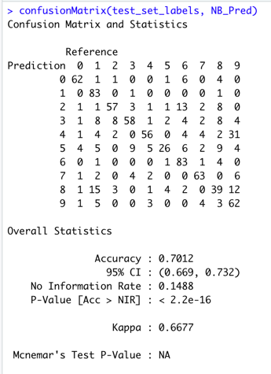

**Figure 45: Naïve Bayes Confusion Matrix and Accuracy**

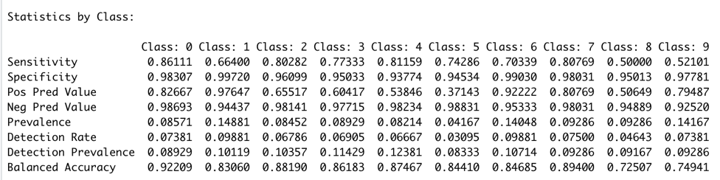

**Figure 45: Naïve Bayes Statistics by Class**

# Decision Tree – Building the Model

Building the Decision Tree model:

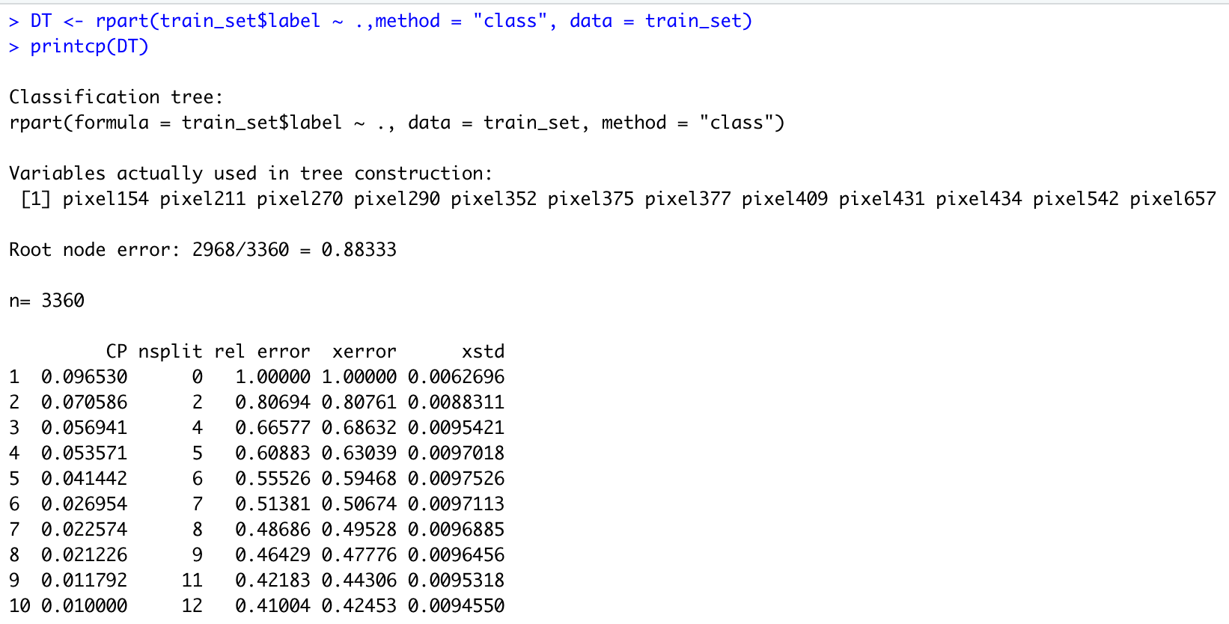

**Figure 46: Decision Tree Building the model**

# Decision Tree – Predication

Predication for Decision Tree:



**Figure 47: Decision Tree Predication**

# Decision Tree – Confusion Matrix and Accuracy

Accuracy received: 58.93%

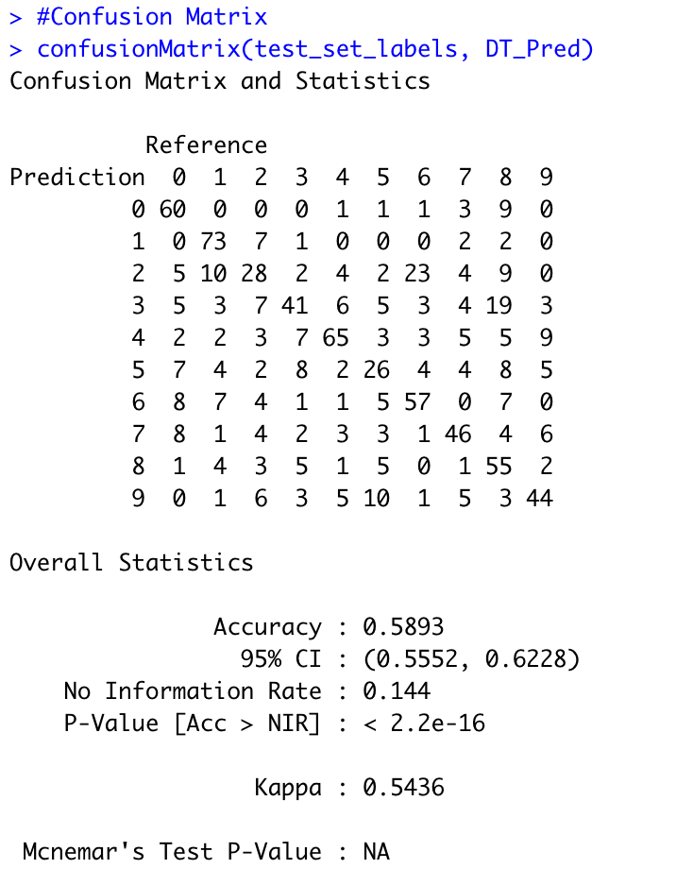

**Figure 48: Decision Tree Decision Matrix and Accuracy**

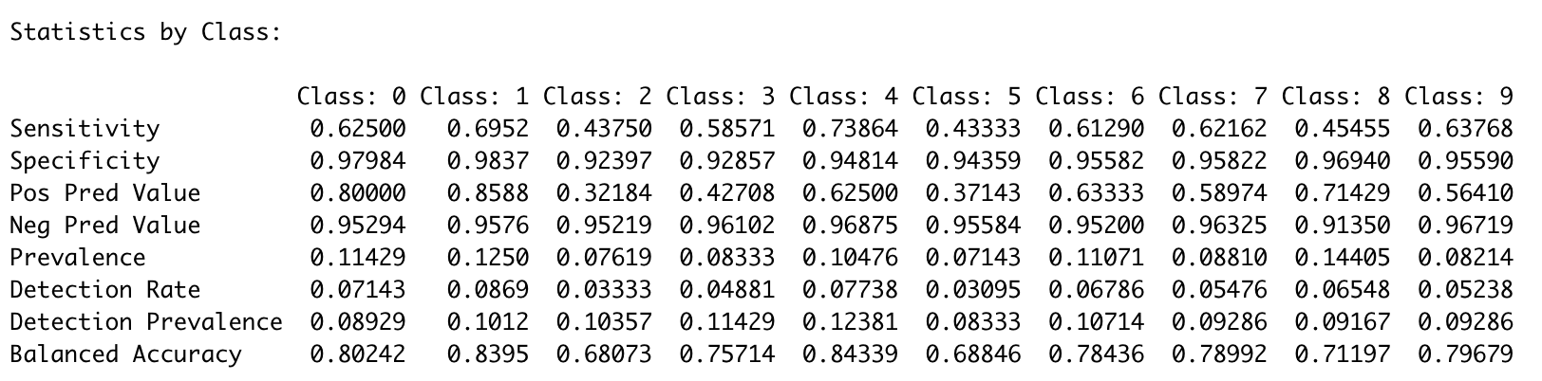

**Figure 48: Decision Tree Decision Statistics by Class**

# Decision Tree – Visualizations

Here are the Decision Tree Visualizations:

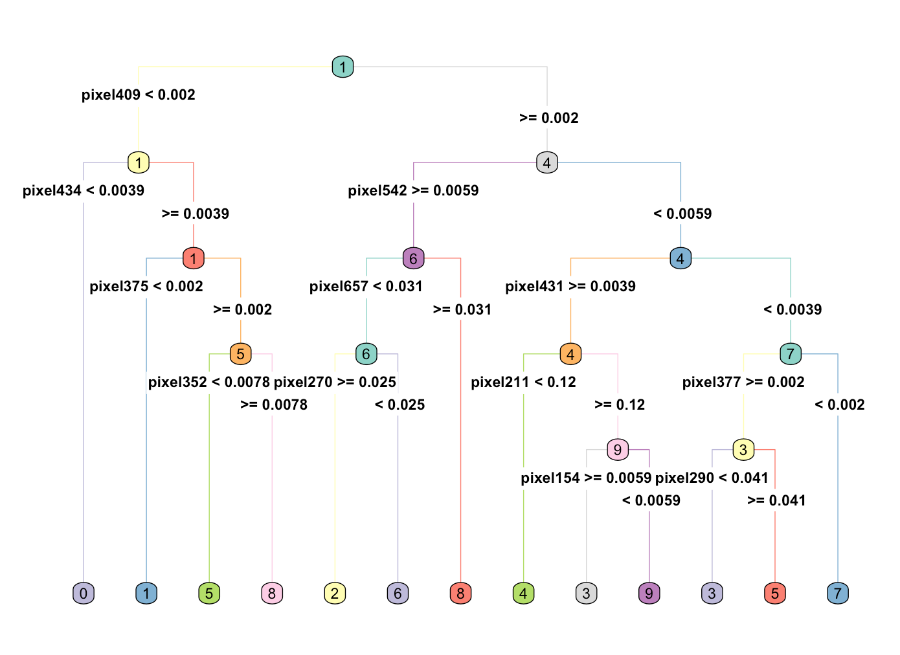

**Figure 49: Decision Tree Visualization – Heat Tree**

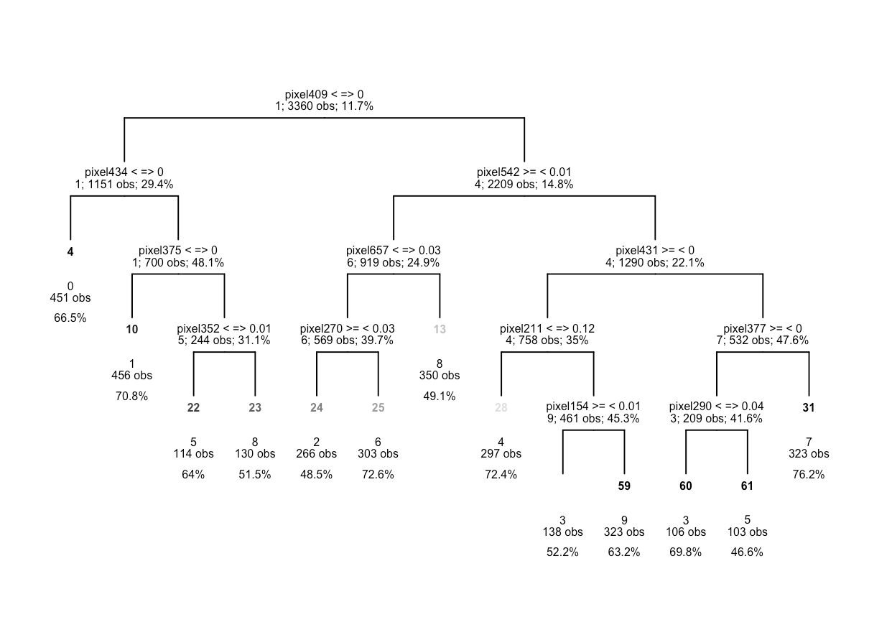

**Figure 50: Decision Tree Visualization – Draw Tree Nodes**

# Results

The accuracy results received are as follows:

kNN: 82.86%

Random Forest: 100%

Support Vector Machine (SVM): 88.45%

Naïve Bayes: 70.12%

Decision Tree: 58.93%

# Conclusions

This research work contributed in so many ways for me as being a Data Scientist. If the researcher had to draw the main reason for the goal of this work, the answer will be pre-processing. Improving the pre-processing mechanism allowed the researcher, to achieve the most accuracy of each algorithms. Building all the algorithms was not the majority of the work but rather, improving the datasets in a way that each algorithm will provide the best results.

The researcher still wondering what was the main reason for low accuracy received in Decision Tree model but if the researcher had to guess what will be the main reason for the low accuracy received, it will probably will indicate that the pre-processing can be improved.

In addition, the researcher realized that the majority of the pre-processing steps did assist to improve the accuracy. Nevertheless, with similar research which requires to combined multiple algorithms, I would consider to separate the low accuracy models from the rest of the algorithms that received high accuracy and build a separate preprocessing model.

Lastly, I would like to Thank Dr. Bolton. His knowledge and guidance allowed me to improve my research goals with all the model. Thank you so much.

# References

<https://www.kaggle.com/c/digit-recognizer>

<https://builtin.com/data-science/random-forest-algorithm>

1. <https://www.kaggle.com/c/digit-recognizer>
2. <https://builtin.com/data-science/random-forest-algorithm>